
USER INTERFACE DESIGN
LAB REPORT

NAME: Rahul Guptha Devisetty

ROLL NO:AV.SC.U4CSE25028

YEAR/SEM/SECTION:1st/SEM-2/CSE-A

Creadits :3

SUBMITTED TO:

NAME: Dr. Rajkumar Batchu Sir

DEPARTMENT: School of Computing

Designation: Associative Professor

INDEX
S.NO | TITLE | PAGE NO: | REMARKS
1. | WEEK1:  1A.Installation of vs code .  1B.understanding basics of HTML .  1C.understanding basics of HTML tags. | 3-13
2. | WEEK 2:  2A.Style Attributes.  2B.To create a small restaurant menu in html | 14-19
3. | WEEK 3: 3A. Construct a class time-table using html tags.  3B. Construct a web page that should display that syllabus of each subject in image format also display the current semester time-table. | 19-31
4. | Week 4:  4A. Forms  4B.College admission registration  4C.User login and user registration form using iframe. | 31-41

WEEK – 1
1A.AIM:Steps to Install VS CODE.
STEP 1: 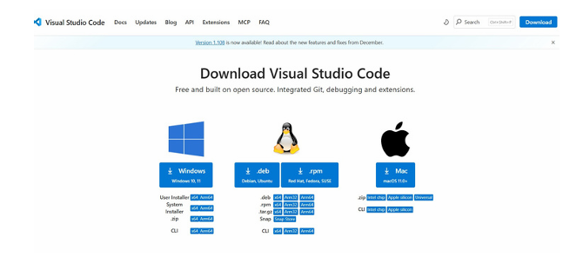
STEP 2: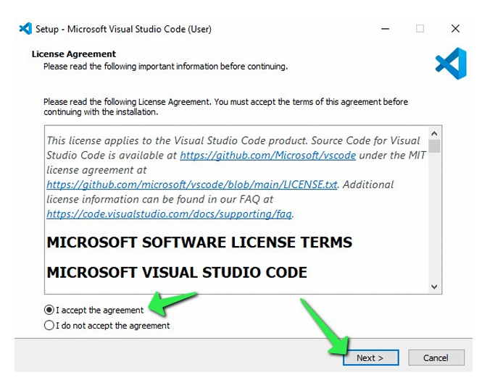

STEP 3:
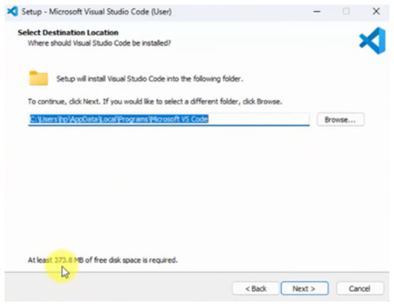
STEP 4:
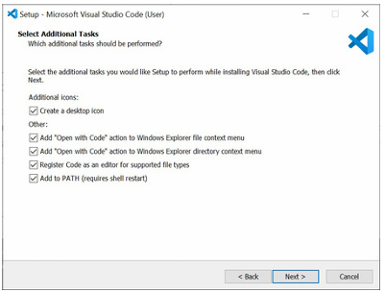
STEP 5:
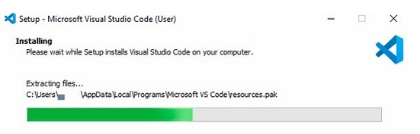

STEP 6:
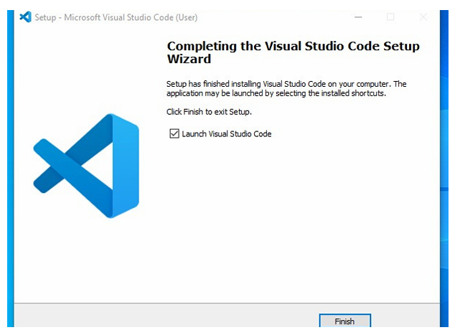
STEP 7:
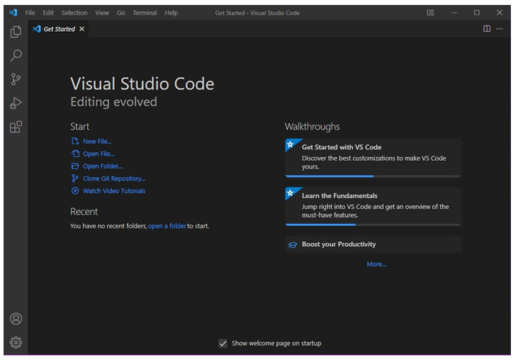

2. AIM: To learn the basics of html( basics.html)
PROGRAM:
UID25028-Rahul Guptha
<!DOCTYPE html>
<html>
<head>
<title>First Web Page</title>
</head>

<body>
<h3>I am in learning stage of HTML</h3>
<p>I like HTML</p>
</body>
</html>
OUTPUT: 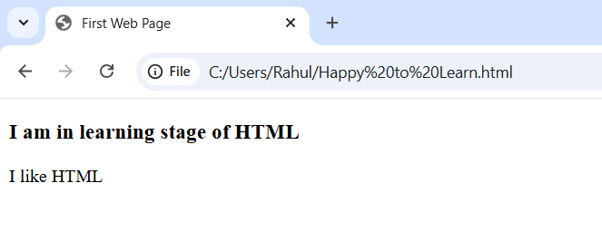

EXPLANATION OF THE TAGS:
• HTML stands for Hyper Text Markup Language.
• HTML is used to create and structure web pages.
• It tells the web browser what to display and how to display it.
• <DOCTYPE HTML>: The <DOCTYPE html>element tells the browser, this is an HTML5 document
• <html>: The <html> element is the root element of an HTML page.
• <The <head> element contains meta information about the HTML page
3. AIM: Understanding basic html tags.
PROGRAM:
<!DOCTYPE html>
<html>
<head>
<title>Games</title>
</head>
<body>
<h1>My favourite Game</h1>
<h2>HTML Images</h2>
<img src="c:\Users\Rahul\Downloads\Free Fire.jpg"
alt="FREE FIRE"
width="100"
height="100">
<h3>HTML Links</h3>
<a href="https://www.amrita.edu">This is a link</a>
<h4 style="background-color: rgb(216, 66, 146);">ABOUT
GAMES</h4>
<p style="background-color: rgb(32, 143, 7);">
Free Fire is a popular mobile game developed by Imangi Studios and released in 2016.
It is an endless running game in which the player controls a character who steals a golden idol from a temple and is chased by dangerous creatures.
The character runs automatically, and the player uses swipe controls to turn, jump, and slide to
avoid obstacles like broken paths, fire traps, and tree roots while collecting coins
</p>
<h4>ABOUT YOURSELF</h4>
<p>
My name is Rahul Guptha.<br>
Section: CSE-A.<br>
Roll No: AV.SC.U4CSE250028.
</p>
</body>
</html>
OUTPUT:
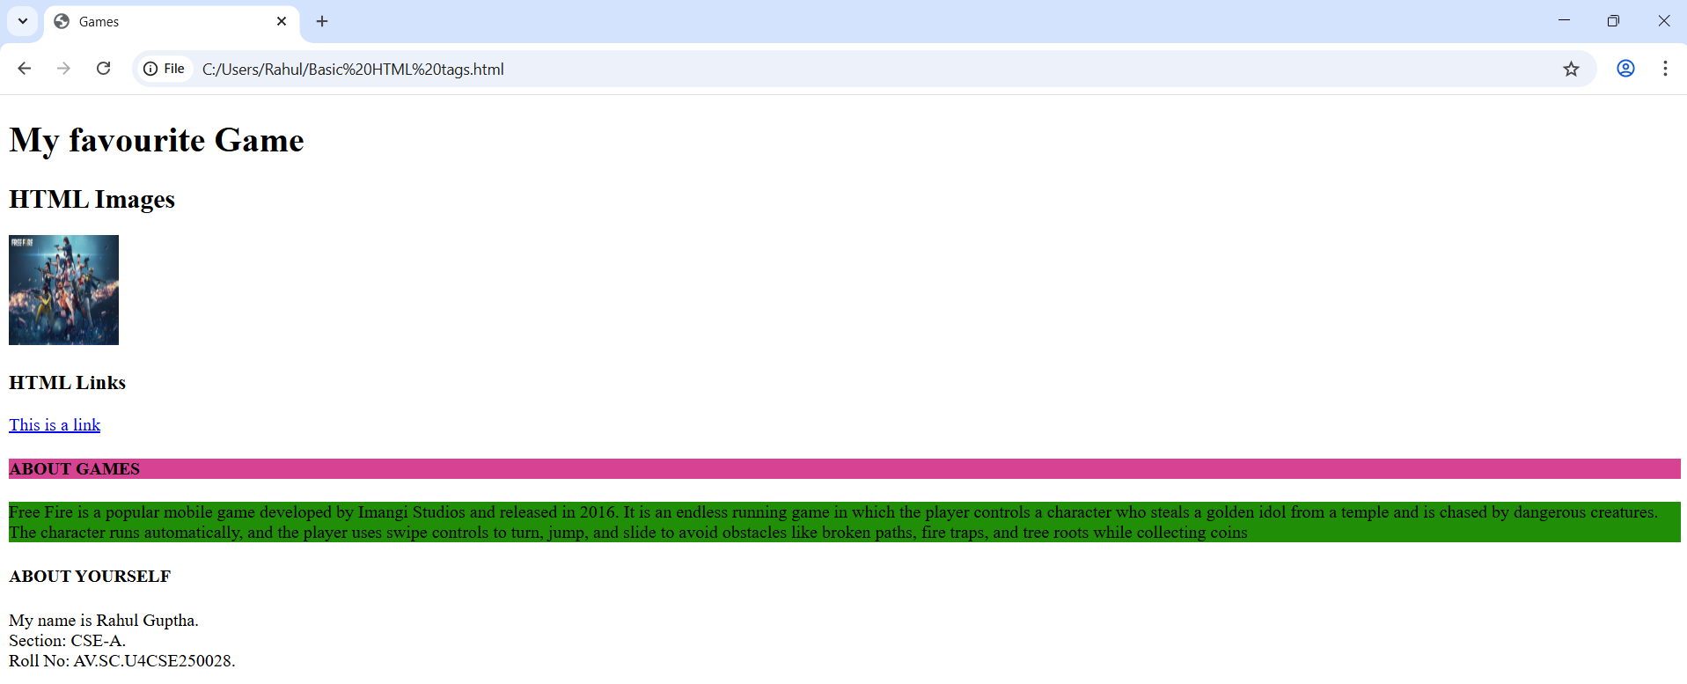
if we click on the link we get amrita website like this
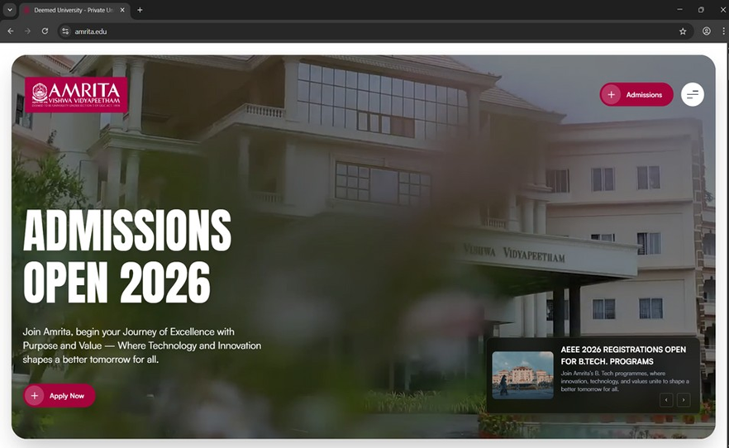
EXPLANATION OF THE TAGS:
•<br>: The HTML <br> element defines a line break. It is an empty tag with no end tag
•Style: The HTML style attribute is used to add styles to an element such as colour, font, size and more
•<img>: The <img> tag is a fundamental HTML element used to embed an image into a web page
• <a>: The HTML <a> tag which stands for “anchor”, is used to define a hyperlink.

WEEK - 2
- AIM : Understanding style attribute and table tags in html.
PROGRAM:
<!DOCTYPE html>
<html>
<head>
<title>My first page</title>
</head>
<body style="background-image:url(amrita.png);background-size: cover;background-repeat: no-repeat;"></body>
<h1 style ="text-align: center; color: rgb(213, 7, 7);border: 3px solid blueviolet;background-color: beige;" >Amrita Vishwavidyapeetham</h1>
<pre style ="font-size: medium; color: rgb(162, 68, 0);font-family: 'Times New Roman', Times, serif;font-style: italic;font-size: large;text-align:center;">
Amrita Vishwa Vidyapeetham is a multi-campus private deemed university in India.
It currently has 19 constituent schools
It is spread across ten campuses in Coimbatore, Amritapuri, Kochi,
Bengaluru, Amaravati, Chennai, Faridabad, Mysore, Nagercoil and Haridwar</pre>
<table style="width: 100%;text-align: center;background-color: beige;border: 3px solid blueviolet;">
<caption style="width:auto;font-size: larger;color: rgb(6, 6, 200);background-color: beige;border-top: 3px solid blueviolet;border-left: 3px solid blueviolet;border-right: 3px solid blueviolet;">TOP COMPANIES</caption>
<tr>
<th>S.no</th>
<th>Company</th>
<th>Founder</th>
<th>Location</th>
</tr>
<tr>
<td>1</td>
<td>Tata Consultancy Services</td>
<td>India</td>
<td>JRD Tata</td>
</tr>
<tr>
<td>2</td>
<td>Capgemini</td>
<td>France</td>
<td>K Serge</td>
</tr>
<tr>
<td>3</td>
<td>Cognizant</td>
<td>India</td>
<td>K Mahadeva</td>
</tr>
<tr>
<td>4</td>
<td>Wipro</td>
<td>India</td>
<td>Azim Prem ji</td>
</tr>
<tr>
<td>5</td>
<td>HCL</td>
<td>India</td>
<td>Shiv Nadar</td>
</tr>
</table>
</body>
</html>
OUTPUT:
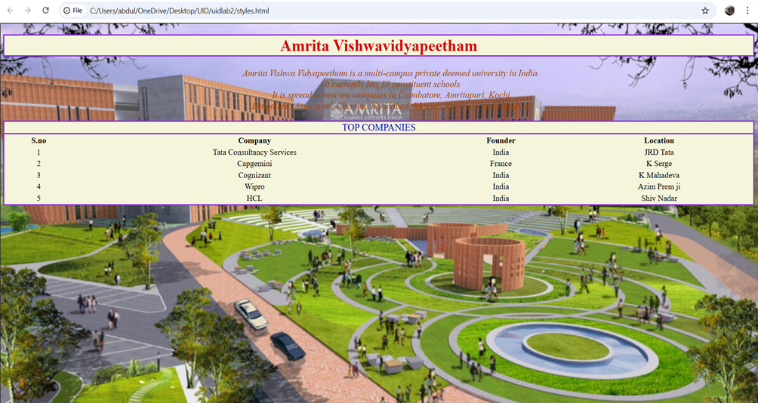
EXPLANATION OF THE TAGS:
• <table> – Creates a table to arrange data in rows and columns.
• <tr> – Defines a table row inside the table.
• <td> – Defines a normal table data cell used to store text, images, or other content.
• <th> > – Defines a table header cell. It is bold and centered by default and is used for headings.
• Style attribute – Used to apply CSS styles directly to an element to control color, alignment, background, font size, spacing, borders, and layout.

2A.AIM: To create a small restaurant menu in html.
INPUT: <!DOCTYPE html>
<html>
<head>
<title>Royal Treats Restaurant</title>
</head>
<body bgcolor="lavender">
<h1 align="center" bgcolor="darkblue">
<font color="white">Royal Treats Restaurant</font>
</h1>
<p align="center">
<font size="4" color="darkblue">
Welcome to Royal Treats Restaurant.<br>
We serve delicious and freshly prepared meals.<br>
Enjoy quality food at the best prices!
</font>
</p>
<h2 align="center"><font color="green">Vegetarian Menu</font></h2>
<table border="2" align="center" width="60%" cellpadding="8">
<tr bgcolor="lightgreen">
<th>Item</th>
<th>Price (₹)</th>
</tr>
<tr><td>Palak Paneer</td><td>190</td></tr>
<tr><td>Veg Pulao</td><td>140</td></tr>
<tr><td>Mix Veg Curry</td><td>160</td></tr>
<tr><td>Rajma Chawal</td><td>130</td></tr>
<tr><td>Paneer Tikka</td><td>210</td></tr>
</table>
<br>
<h2 align="center"><font color="red">Non-Vegetarian Menu</font></h2>
<table border="2" align="center" width="60%" cellpadding="8">
<tr bgcolor="lightpink">
<th>Item</th>
<th>Price (₹)</th>
</tr>
<tr><td>Chicken Biryani</td><td>230</td></tr>
<tr><td>Chicken Tikka</td><td>220</td></tr>
<tr><td>Mutton Curry</td><td>280</td></tr>
<tr><td>Fish Curry</td><td>250</td></tr>
<tr><td>Egg Fried Rice</td><td>150</td></tr>
</table>
<br><br>
<p align="center">
<b>Thank You for Visiting!</b>
</p>
</body>
</html>
OUTPUT:
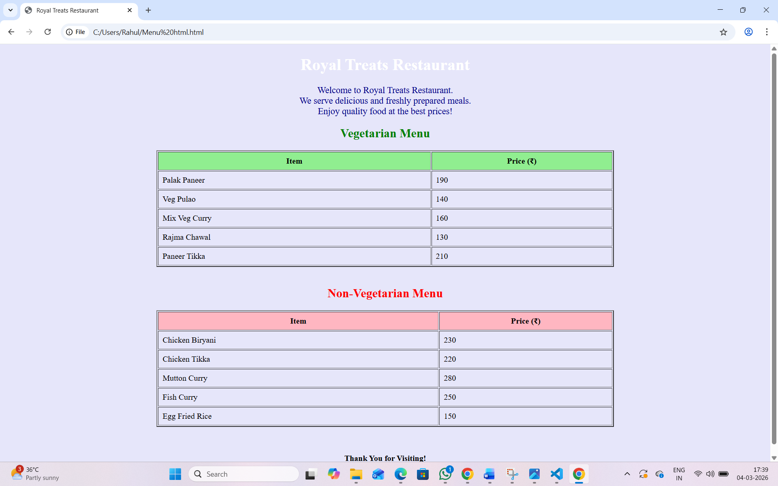

EXPLANATION OF THE TAGS:

• <u> – Underlines the enclosed text to give it visual emphasis.
• <b> – Displays text in bold without indicating extra importance.
• <strong> – Marks text as strongly important and usually displays it in bold.
• <sub> – Shows text as subscript below the normal text line.
• <i> – Displays text in italic style to indicate a term or emphasis.
• <sup> – Shows text as superscript above the normal text line.
• <del> – Represents deleted or removed text with a strike- through.
• <mark> – Highlights text to indicate special importance or relevance.
• <table> – Creates a table to arrange data in rows and columns.
• <tr> – Defines a table row inside the table.
• <td> – Defines a normal table data cell used to store text, images, or other content.
• <th> > – Defines a table header cell. It is bold and centered by default and is used for headings.
• Style attribute – Used to apply CSS styles directly to an element to control color, alignment, background, font size, spacing, borders, and

WEEK - 3
3A.AIM:Construct a class time-table using html tags.
PROGRAM:
<!DOCTYPE html>
<html>
<head>
<title>html tables</title>
</head>
<body>
<h1 style="text-align: center;">TIME TABLE</h1>
<table width="80%" border="2" text-align="center" style="border-collapse: collapse;" cell-spacing="5" cell-padding="5">
<caption style="color: blue;font-size: larger;">Master Time Table CSE Semester-|| A Section</caption>
<tr style="border: 2px solid black;">
<th rowspan="2">Time/Day</th>
<th>Slot 1</th>
<th>Slot 2</th>
<th rowspan="2">10:35am-10:45am</th>
<th>Slot 3</th>
<th>Slot 4</th>
<th>Slot 5</th>
<th rowspan="2">01:15-02:05pm</th>
<th>Slot 6</th>
<th>Slot 7</th>
<th>Slot 8</th>
</tr>
<tr>
<th>08:55-09:45am</th>
<th>09:45-10:35am</th>
<th>10:45-11:35am</th>
<th>11:35-12:25pm</th>
<th>12:25-01:15pm</th>
<th>02:10-03:00pm</th>
<th>03:10-04:00</th>
<th>04:00-04:50pm</th>
</tr>
<tr style="border: 2px solid black;">
<td>Monday</td>
<td>23CSE111Object Oriented Programming</td>
<td>23CSE113UserInterfaceDesign</td>
<td rowspan="5" style="background-color:yellow;">SHORT BREAK</td>
<td colspan="2">23MAT116 Discrete Mathematics_lab_lab3</td>
<td>LIBRARY</td>
<td rowspan="5" style="background-color: yellow;">LUNCH BREAK</td>
<td>LIBRARY</td>
<td colspan="2">LIBRARY/SPORTS</td>
</tr>
<tr style="border: 2px solid black;">
<td>Tuesday</td>
<td colspan="2">23CSE111ObjectOriented Programming_lab1</td>
<td>23MAT116 Discrete Mathematics</td>
<td colspan="2">23MAT117 Linear Algebra_LAB(BYOD)</td>
<td>Library</td>
<td colspan="2">22ADM111 Glimpses Of Glorious India</td>
</tr>
<tr style="border: 2px solid black;">
<td>Wednesday</td>
<td>23PHY115 Modern Physics</td>
<td>23MAT117 Linear Algebra</td>
<td>LIBRARY</td>
<td>23PHY115 Modern Physics</td>
<td>23CSE111Object Oriented Programming</td>
<td>23MEE115 Manufacturing Practice LAB</td>
<td colspan="2">23MEE115 Manufacturing Practice LAB</td>
</tr>
<tr style="border: 2px solid black;">
<td>Thursday</td>
<td>23CSE113 User Interface Design</td>
<td>23MAT117 Linear Algebra</td>
<td colspan="2">23CSE113 User Interface Design Lab (BYOD)</td>
<td>23MAT116 Discrete Mathematics</td>
<td style="color:red;">COUNSELLING</td>
<td colspan="2">Library/Sports</td>
</tr>
<tr style="border: 2px solid black;">
<td>Friday</td>
<td>23MAT117 Linear Algebra</td>
<td>23PHY115 Modern Physics</td>
<td>23CSE111Object Oriented Programming</td>
<td>23MAT116 Discrete Mathematics</td>
<td style="color:red;">COUNSELLING</td>
<td>22ADM111 Glimpses Of Glorious India</td>
<td colspan="2">Library/Sports</td>
</tr>
<tr style="font-size: larger;" style="border: 2px solid black;">
<td>Course Code</td>
<td colspan="4" style="text-align:center;">Course Name</td>
<td>Credits</td>
<td colspan="5">Faculty Name</td>
</tr>
<tr style="font-size: larger;" style="border: 2px solid black;">
<td>23MAT116</td>
<td colspan="4">Discrete Mathematics</td>
<td>4</td>
<td colspan="5">Dr.Ram Pratap Chauhan</td>
</tr>
<tr style="font-size: larger;" style="border: 2px solid black;">
<td>23MAT117</td>
<td colspan="4">Linear Algebra</td>
<td>4</td>
<td colspan="5">Dr.Rashmi Prasad</td>
</tr>
<tr style="font-size: larger;" style="border: 2px solid black;">
<td>23CSE111</td>
<td colspan="4">Object 23CSE111ObjectOrientedProgramming</td>
<td>4</td>
<td colspan="5">Dr.Balaji TK</td>
</tr>
<tr style="font-size: larger;" style="border: 2px solid black;">
<td>23PHY115</td>
<td colspan="4">Modern Physics</td>
<td>3</td>
<td colspan="5">Dr.C.R Kesavulu</td>
</tr>
<tr style="font-size: larger;" style="border: 2px solid black;">
<td>23CSE113</td>
<td colspan="4">User Interface Design</td>
<td>3</td>
<td colspan="5">Dr.Rajkumar Batchu</td>
</tr>
<tr style="font-size: larger;" style="border: 2px solid black;">
<td>23MEE115</td>
<td colspan="4">Manufacturing Practice</td>
<td>1</td>
<td colspan="5">Dr.Sathies S</td>
</tr>
<tr style="font-size: larger;" style="border: 2px solid black;">
<td>22ADM111</td>
<td colspan="4">Glimpses Of Glorious India</td>
<td>2</td>
<td colspan="5">Dr.Siva Panuganti</td>
</tr>
</table>
</body>
</html>

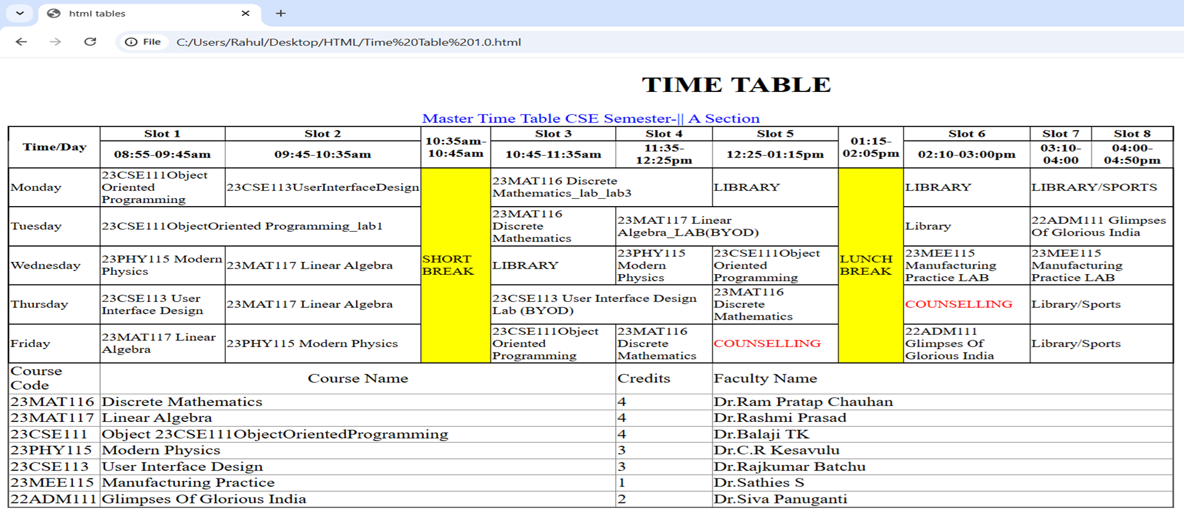
OUTPUT:
EXPLANATION OF THE TAGS:
• <!DOCTYPE html> tells the browser this is a webpage.
• <html> starts and ends the webpage.
• <head> contains page details.
• <title> shows webpage name on browser tab.
• <body> shows all content on the screen.
• Font style is changed using font-family.
• Margin gives space around the page.
• <h2> shows the main timetable heading.
• <h3> shows class and semester details.
• <table> is used to create timetable structure.
• border="1" adds lines around the table.
• <tr> is used to create rows.
• <td> is used to enter data in rows.
• <th> is used to create headings in table.
• <colspan> is used when one subject covers two periods.
• <rowspan> is used when break or lunch covers many rows.
• <br> is used to move text to the next line.
• Yellow background is used to highlight break and lunch.
Different rows represent different days of the week.
Another table is used to show course code, faculty name, and credits.
3B.AIM:Construct a web page that should display that syllabus of each subject in image format also display the current semester time-table.
INPUT: <DOCTYPE html>
<html>
<head>
<title>Semester Syllabus</title>
</head>
<body>
<p style="color: blue;text-align: center;font-size: xx-large;">Discrete Mathematics</p>
<img src=" c:\Users\Rahul\Pictures\Screenshots\Screenshot 2026-02-11 230218.png" width="100%">
<p style="color: crimson;text-align: center;font-size: xx-large;">Linear Algebra</p>
<img src="c:\Users\Rahul\Pictures\Screenshots\Screenshot 2026-02-11 230037.png" width="100%">
<p style="color: darkgoldenrod;text-align: center;font-size: xx-large;">Object Oriented Programming</p>
<img src="c:\Users\Rahul\Pictures\Screenshots\Screenshot 2026-02-11 230353.png" width="100%">
<p style="color: darkgreen;text-align: center;font-size: xx-large;">Modern Physics</p>
<img src="c:\Users\Rahul\Pictures\Screenshots\Screenshot 2026-02-11 230514.png" width="100%">
<p style="color: darkmagenta;font-size: xx-large;text-align: center;">User Interface Design</p>
<img src="c:\Users\Rahul\Pictures\Screenshots\Screenshot 2026-02-11 230625.png" width="100%">
<p style="color: lawngreen;font-size: xx-large;text-align: center;">Manufacturing Practice</p>
<img src="c:\Users\Rahul\Pictures\Screenshots\Screenshot 2026-02-11 230721.png" width="100%">
<p style="font-size: xx-large;color: navy;text-align: center;">Glimpses Of Glorious India</p>
<img src="c:\Users\Rahul\Pictures\Screenshots\Screenshot 2026-02-11 230902.png" width="100%">
</body>
</html>
OUTPUT: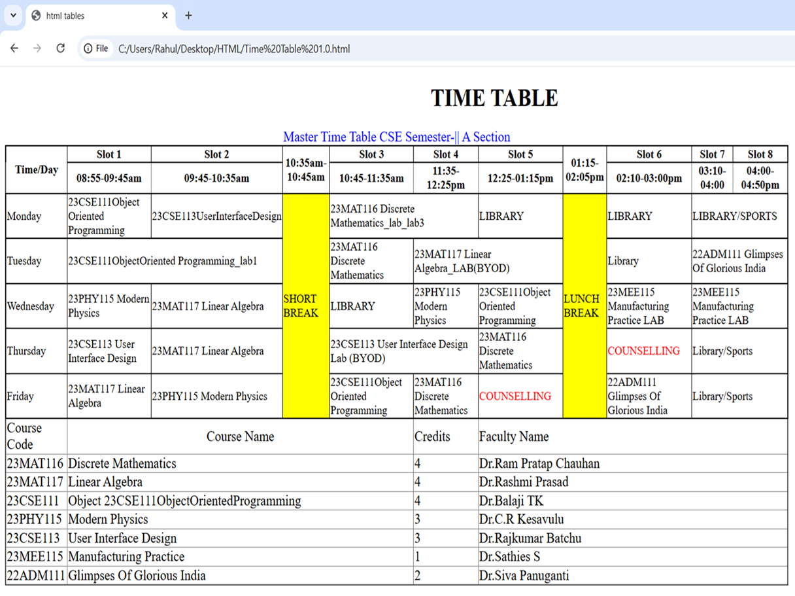
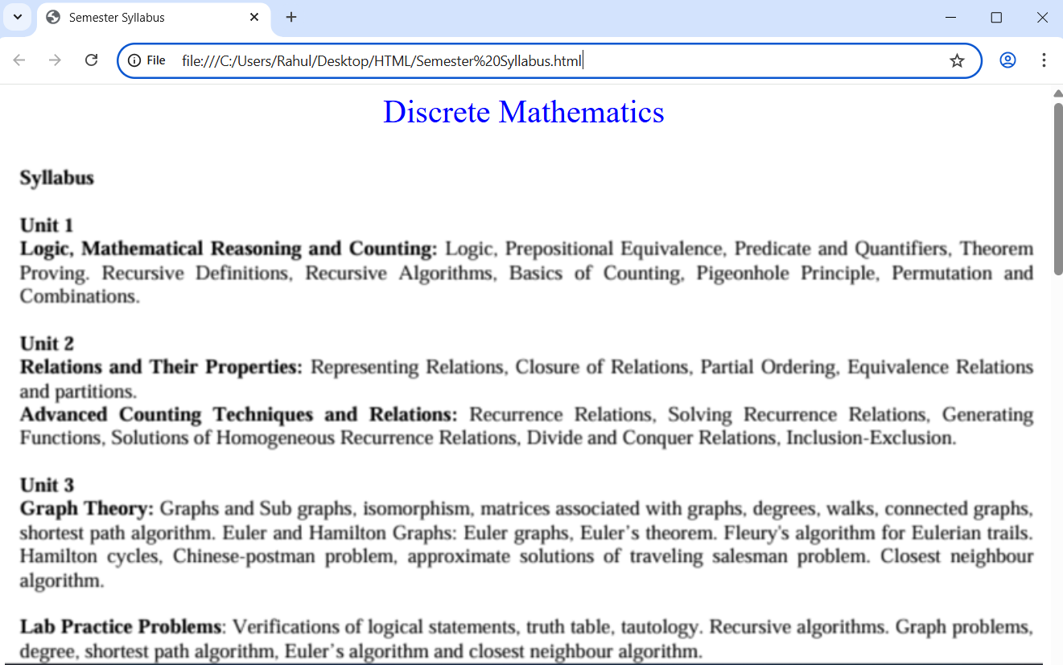

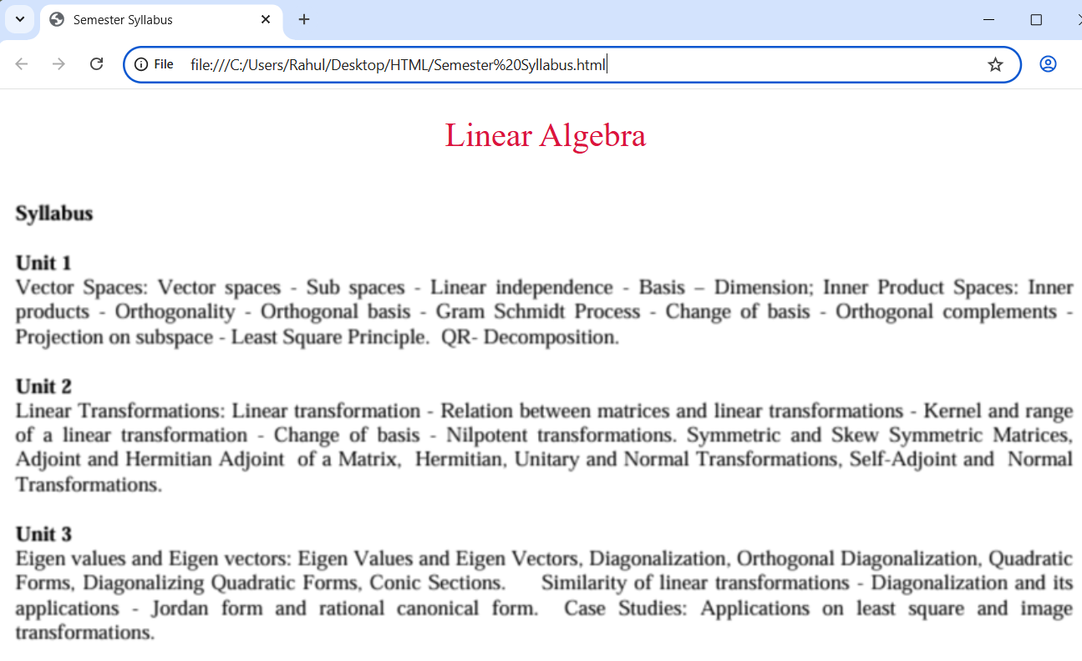

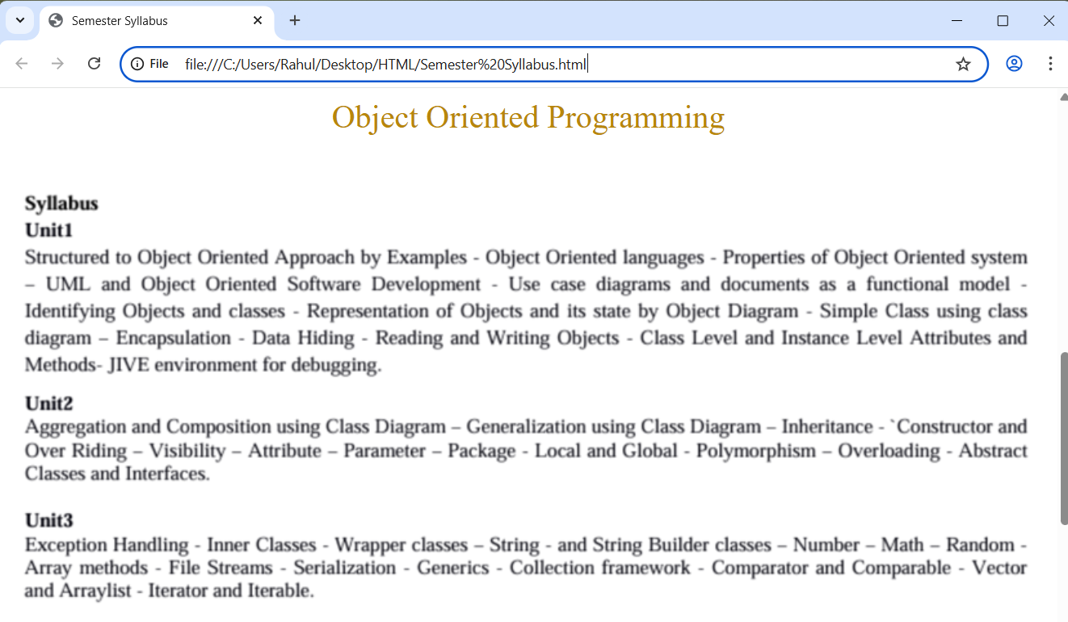

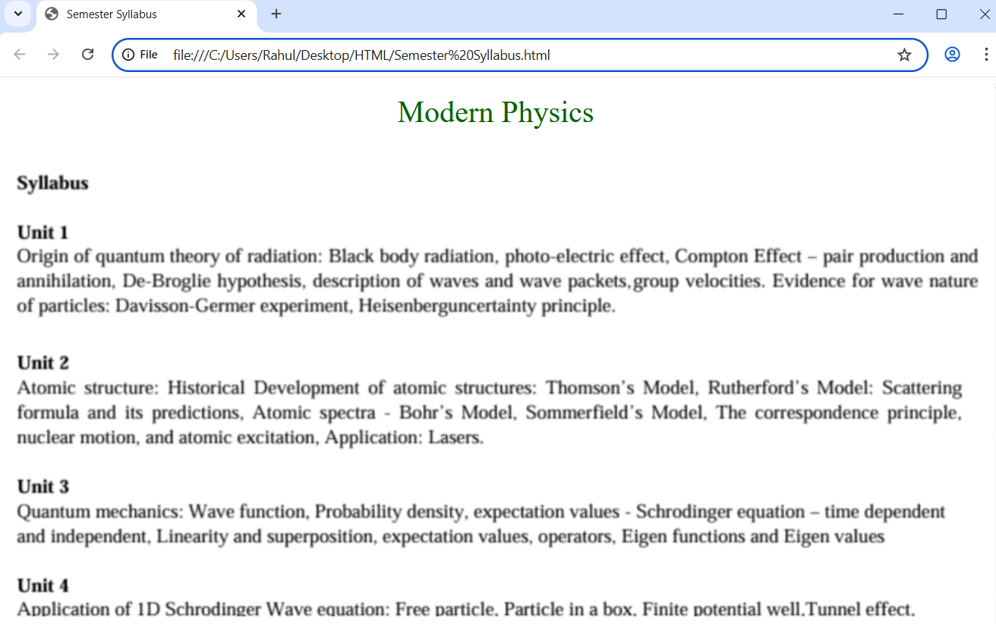
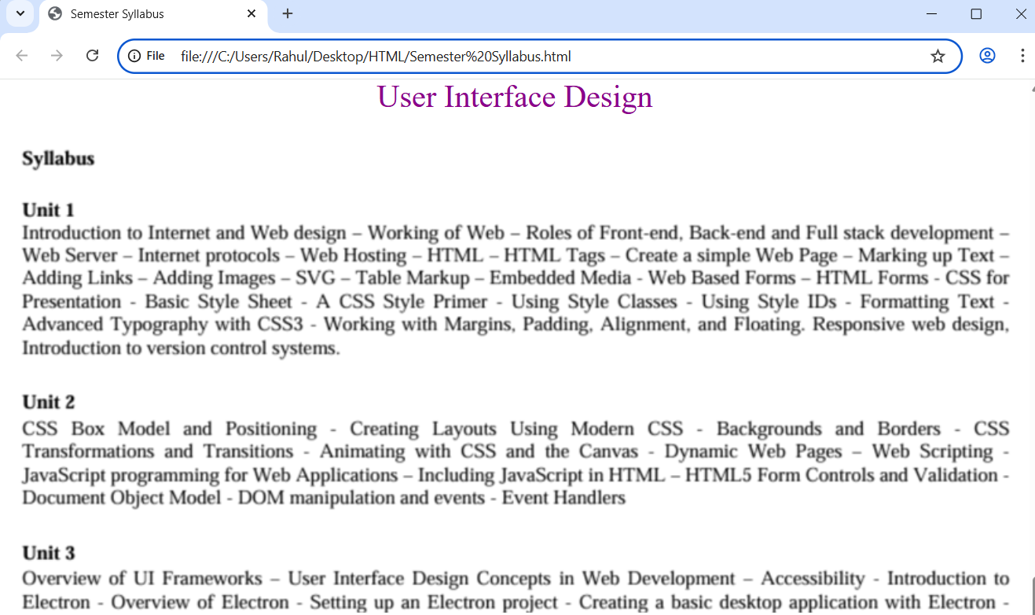

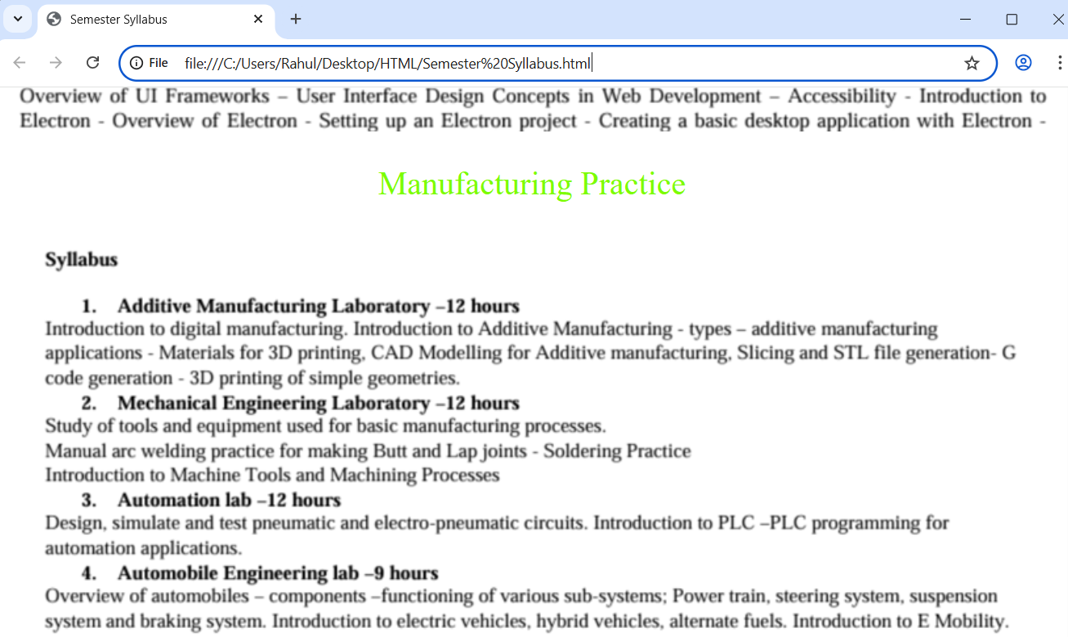
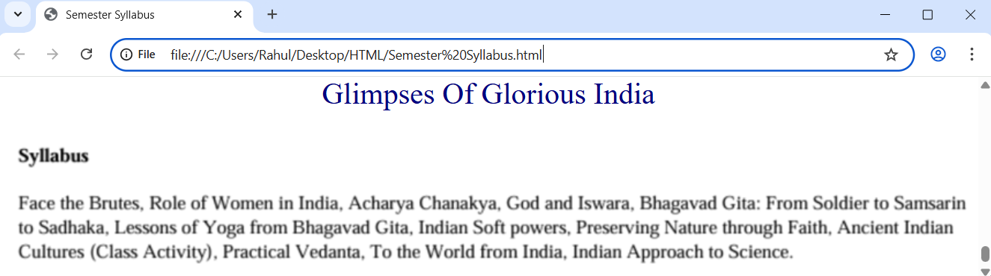
EXPLANATION OF THE TAGS:
• <!DOCTYPE html> tells the browser this is a webpage.
• <html> starts and ends the webpage.
• <head> contains page details.
• <title> shows webpage name on browser tab.
• <body> shows all content on the screen. Font style is changed using font-family. Margin gives space around the page.
• <h2> shows the main timetable heading.
WEEK – 4
4A.AIM: To understand the concept of forms (input from user).
CODE: <!DOCTYPE html>
<html>
<head>
<title>Forms Example</title>
</head>
<body>
<h2>The input element</h2>
<form>
<label for="name">Name:</label><br>
<input type="text" id="name" name="name"><br><br>
<label for="email">Email:</label><br>
<input type="email" id="email" name="email"><br><br>
<input type="submit" value="Submit">
<input type="reset" value="Reset"><br><br>
<label for="branch">Branch:</label><br>
<select id="branch" name="branch">
<option value="">Select Branch</option>
<option value="cse">Computer Science</option>
<option value="aie">AI</option>
<option value="cce">CCE</option>
<option value="aids">AIDS</option>
</select><br><br>
<select id="year" name="year"size ="4">
<option value="1st">1st Year</option>
<option value="2nd">2nd Year</option>
<option value="3rd">3rd Year</option>
<option value="4th">4th Year</option>
</select><br><br>
</form>
</body>
OUTPUT:
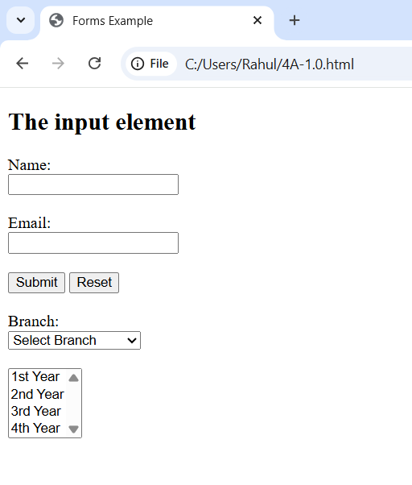
EXPLANATION OF THE TAGS:
• <form> – Used to create an HTML form for user input.
• <label> – Defines a label for an input field. It improves accessibility and user understanding.
• <input> – Used to create input fields. It can take different types like:
• <select> – Creates a drop-down list.
• <option> – Defines options inside the drop-down list.
• id attribute – Uniquely identifies an element.
• name attribute – Used to send form data to the server.
• size attribute – Specifies how many options are visible in a select box.
• <textarea> – Used for multi-line text input like address.
• <button> – Creates clickable buttons like Submit and Reset.
• <iframe> – Used to display another webpage inside the current webpage
4B.AIM: A college wants to collect student details through an online admission form. Design a registration form using only html tags (no CSS) with proper labels, table, alignment, background ` color and borders.
PROGRAM:
<!DOCTYPE html>
<html>
<body style="background-color: beige;">
<h2 style = "text-align: center;">College Admission Registration</h2>
<table align="center" border="1px" cellspacing="0" cellpadding="10" style="background-color: bisque;">
<tr>
<th><label for="fname">Full Name:</label></th>
<td><input type="text" id="fname" placeholder="Enter Your Full name"></td>
</tr>
<tr>
<th><label for ="email">Email:</label></th>
<td><input type="email" id="email" placeholder="Enter Your Email"></td>
</tr>
<tr>
<th><label for="pnum">Phone Number:</label></th>
<td><input type="number" id="pnum" placeholder="enter Your Phone Number"></td>
</tr>
<tr>
<th><label for="g">Gender:</label></th>
<td>
<input type="radio" id="g" name="Gender">Male
<input type="radio" id="g" name="Gender">Female
<input type="radio" id="g" name="Gender">Other
</td>
</tr>
<tr>
<th><label for="c">Course Application:</label></th>
<td><select id="c">
<option>B-tech</option>
<option>B-arch</option>
<option>BBA</option>
</select></td>
</tr>
<tr>
<th><label for="h">Hobies:</label></th>
<td>
<input type="radio" id="h" name="Hobies">Sports
<input type="radio" id="h" name="Hobbies">Music
<input type="radio" id="h" name="Hobbies">Reading
</td>
</tr>
<tr>
<th><label for="date">Date of Birth:</label></th>
<td><input type="date"></td>
</tr>
<tr>
<th><label for="up">Upload Certificate:</label></th>
<td><input type="file" id="up"></td>
</tr>
<tr>
<th><label for="a">Address:</label></th>
<td><textarea rows="10" cols="30" placeholder="Enter Your Address"></textarea></td>
</tr>
<tr>
<th colspan="2"><input type="submit"> <input type="reset"></th>
</tr>
</table>
</body>
</html>
OUTPUT: 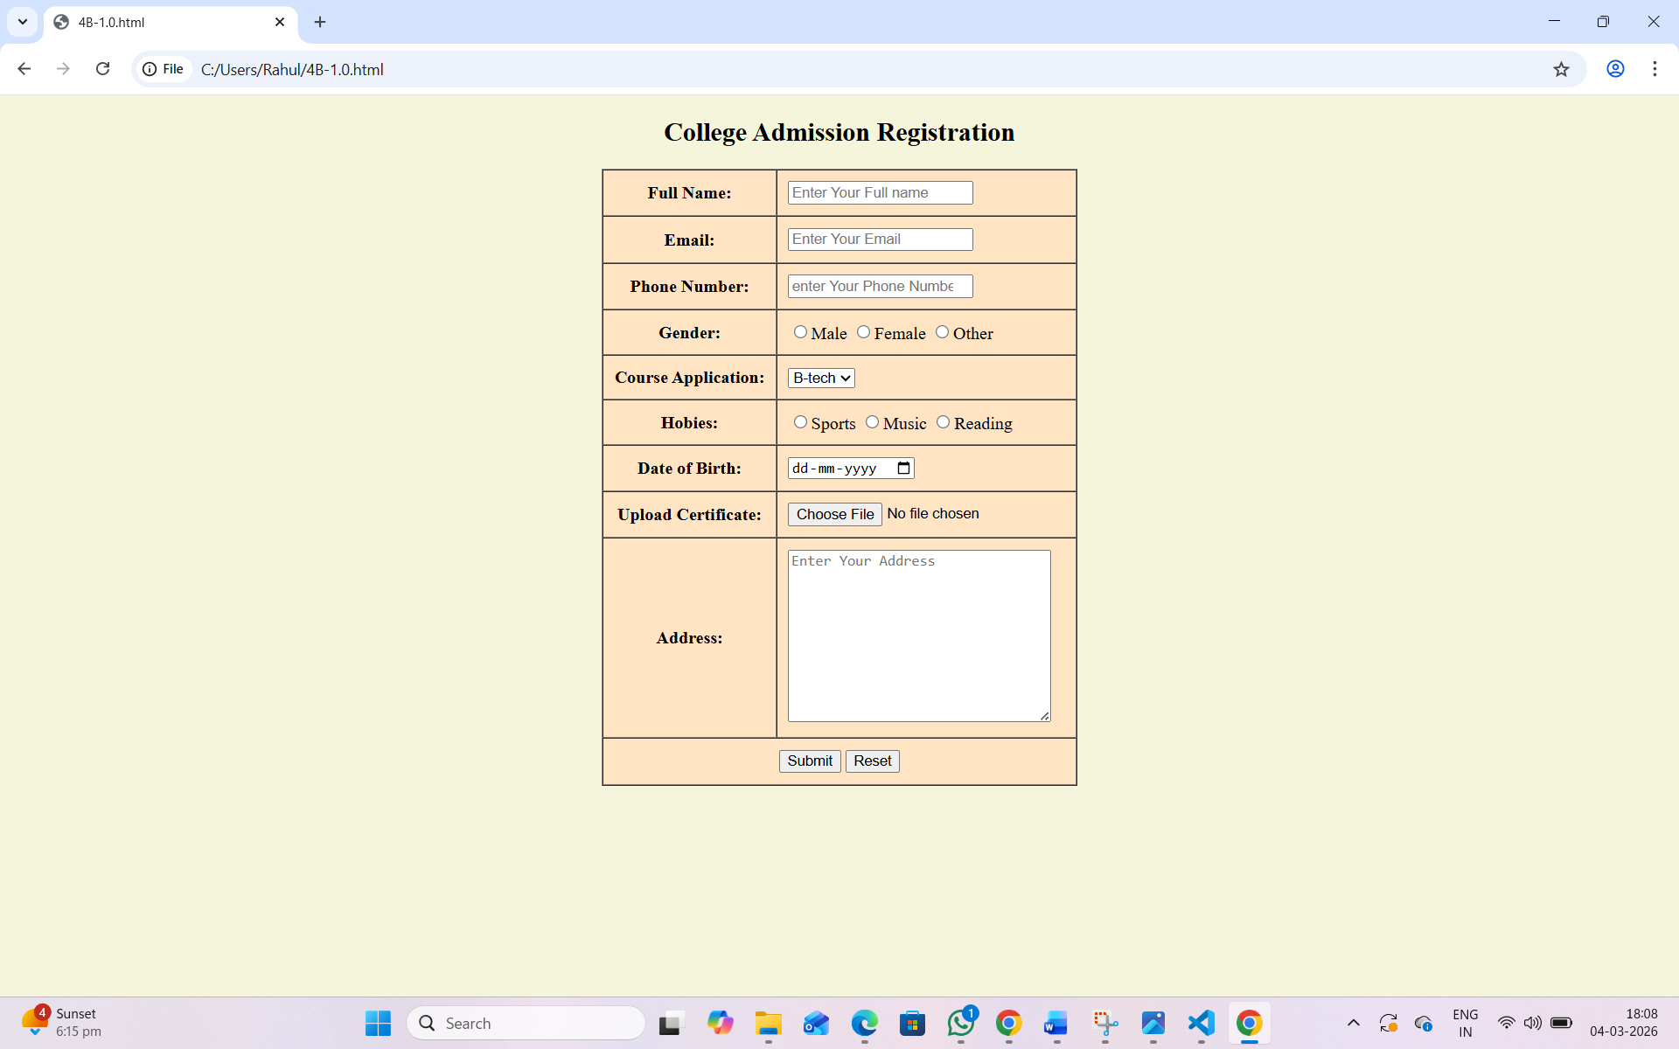
EXPLANATION OF THE TAGS:
<form> – Used to create an HTML form for user input.
• <label> – Defines a label for an input field. It improves accessibility and user understanding.
• <input> – Used to create input fields. It can take different types like:
• <select> – Creates a drop-down list.
• <option> – Defines options inside the drop-down list.
• id attribute – Uniquely identifies an element.
• name attribute – Used to send form data to the server.
• size attribute – Specifies how many options are visible in a select box.
• <textarea> – Used for multi-line text input like address.
• <button> – Creates clickable buttons like Submit and Reset.
• <iframe> – Used to display another webpage inside the current webpage
4C.AIM: Design a user login and user registration form using iframe with proper labels, table, alignment, background color and borders.
PROGRAM:
<!DOCTYPE html>
<html>
<head>
<title>4B</title>
</head>
<body>
<table width="100%">
<tr>
<td width="50%" align="center">
<iframe src="4Blogin.html" width="100%" height="400"></iframe>
</td>
<td width="50%" align="center">
<iframe src="4Bregister.html" width="100%" height="400"></iframe>
</td>
</tr>
</table>
</body>
</html>
<!DOCTYPE html>
<html>
<head>
<title>Login</title>
</head>
<body style="background-color: rgb(233, 161, 120);">
<h1 style="text-align:center">User Login</h1>
<form>
<table border="3" align="center" cellpadding="10">
<tr>
<td>
<label for="username">Username:</label>
</td>
<td>
<input type="text" id="username">
</td>
</tr>
<tr>
<td>
<label for="password">Password:</label>
</td>
<td>
<input type="password" id="password">
</td>
</tr>
<tr>
<td colspan="2" align="center">
<button type="submit">Login</button>
</td>
</tr>
</table>
</form>
</body>
</html>
<!DOCTYPE html>
<html>
<head>
<title>Register</title>
</head>
<body style="background-color:rgb(231, 193, 40)">
<h1 style="text-align:center">User registration</h1>
<form>
<table border="3px" align="center" cellpadding="10">
<tr>
<td><label for="fullname">Full Name:</label></td>
<td><input type="text" id="fullname"></td>
</tr>
<tr>
<td><label for="email">Email:</label></td>
<td><input type="text" id="email"></td>
</tr>
<tr>
<td><label for="phone">Phone number:</label></td>
<td><input type="text" id="phone"></td>
</tr>
<tr>
<td><label for="password">Password:</label></td>
<td><input type="password" id="password"></td>
</tr>
<tr>
<td colspan="2" align="center">
<button type="submit">Register</button>
<button type="submit">Reset</button>
</td>
</tr>
</table>
</form>
</body>
</html>
OUTPUT: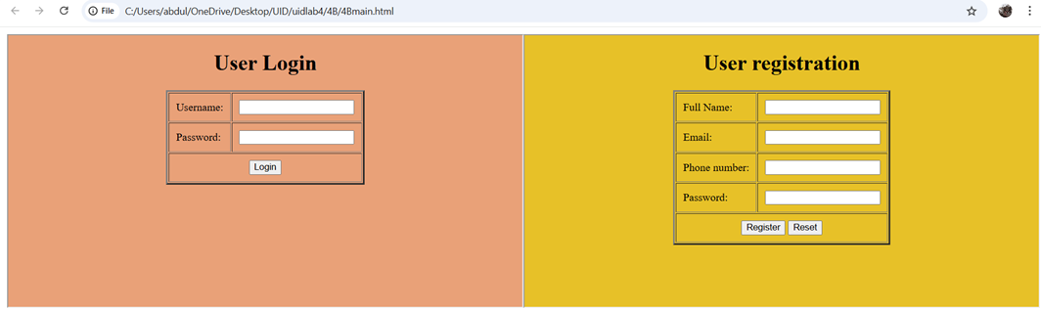

WEEK – 5
5A.AIM:Create a card layout using new tag consider 3 cards and a button for each and using html and css.
CODE: <!DOCTYPE html>
<html lang="en">
<head>
<meta charset="UTF-8">
<title>Image Card Layout</title>

<style>

body{
font-family: Arial;
background:#f2f2f2;
}

.card-container{
display:flex;
justify-content:center;
gap:30px;
margin-top:40px;
}

.card{
width:250px;
text-align:center;
}

.card img{
width:100%;
height:auto;
}

.image-box{
position:relative;
}

.image-box button{
position:absolute;
bottom:10px;
left:50%;
transform:translateX(-50%);
padding:8px 15px;
background:blue;
color:white;
border:none;
border-radius:5px;
cursor:pointer;
}

</style>
</head>

<body>

<section class="card-container">

<article class="card">

<div class="image-box">
<img src="c:\Users\Rahul\Pictures\Screenshots\Screenshot 2026-02-26 115140.png" alt="Card Image">
<button>Read More</button>
</div>

<h2>Card 1</h2>

</article>

<article class="card">

<div class="image-box">
<img src="c:\Users\Rahul\Pictures\Screenshots\Screenshot 2026-02-26 115140.png" alt="Card Image">
<button>Read More</button>
</div>

<h2>Card 2</h2>

</article>

<article class="card">

<div class="image-box">
<img src="c:\Users\Rahul\Pictures\Screenshots\Screenshot 2026-02-26 115140.png" alt="Card Image">
<button>Read More</button>
</div>

<h2>Card 3</h2>

</article>

</section>

</body>
</html>
OUTPUT:
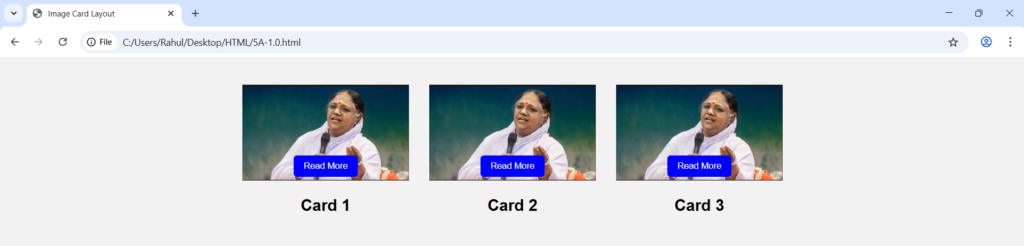
EXPLANATION OF TAGS:
<DOCTYPE html> : the <!DOCTYPE html> element tells the web browser that this an HTML document
or this is the latest version of HTML
<html> : the <html> element is the root element of an HTML web page
<head> : the <head> element will contain meta data about the HTML web page
<title> : the <title> element specifies a title for the HTML Page
<body> : the <body> element contains all visible content all visible content like text , image , links ,
tables , etc
<h> : we used <h> element for heading
<p> : we used <p> element for the paragraph
<div>:we use <div> element for encapsulating the the divisions and easy to modify and
<button>: we use <button> element for button
<img>: we use <img> tag for displaying the image
5B.AIM: Create a mini-website using iframe with navigation {Home,About,Contact} the display content in the same page.
CODE:
<!DOCTYPE html>
<html>
<head>
<title>Mini Website - Amrita</title>

<style>
body{
margin:0;
font-family: Arial, sans-serif;
}

.header{
background: red
(31, 6, 221);
color:rgb(170, 239, 7);
text-align:center;
padding:15px;
}

.nav{
background:black;
text-align:center;
padding:12px;
}

.nav label{
color:rgb(192, 217, 3);
margin:0 20px;
font-size:18px;
cursor:pointer;
}

.nav label:hover{
color:rgb(3, 215, 56);
}

iframe{
width:100%;
height:500px;
border:none;
}

input{
display:none;
}

.content{
display:none;
}

#home:checked ~ #homeFrame,
#about:checked ~ #aboutFrame,
#contact:checked ~ #contactFrame{
display:block;
}
</style>
</head>

<body>

<div class="header">
<h2>Amrita Vishwa Vidyapeetham</h2>
</div>

<!-- Hidden Radio Buttons -->
<input type="radio" name="menu" id="home" checked>
<input type="radio" name="menu" id="about">
<input type="radio" name="menu" id="contact">

<!-- Navigation -->
<div class="nav">
<label for="home">Home</label>
<label for="about">About</label>
<label for="contact">Contact</label>
</div>

<!-- HOME PAGE -->
<iframe id="homeFrame" class="content" srcdoc="
<html>
<body style='font-family:Arial;padding:20px;text-align:center;'>

<h2>Welcome to Amrita Vishwa Vidyapeetham</h2>

<img src='amrita.jpg' width='60%' style='border-radius:10px;'>

<p>Amrita University Campus View</p>

</body>
</html>
">
</iframe>

<!-- ABOUT PAGE -->
<iframe id="aboutFrame" class="content" srcdoc="
<html>
<body style='font-family:Arial;padding:20px;'>

<h2>About Us</h2>

<p>Amrita Vishwa Vidyapeetham is a multi-disciplinary private university offering Engineering, Medical, and Management programs.</p>

<p>Amrita Vishwa Vidyapeetham is a multi-disciplinary, research-intensive private university with a student strength of over 30,000, supported by more than 2,000 faculty members.</p>

<p>With a network of ten campuses located in Amaravati, Amritapuri, Bengaluru, Chennai, Coimbatore, Kochi, Mysuru, Nagercoil, NCR Delhi (Faridabad), and Haridwar.</p>

<p>Amrita Vishwa Vidyapeetham has been ranked 8th in the National Institutional Ranking Framework (NIRF) 2025.</p>

</body>
</html>
">
</iframe>

<!-- CONTACT PAGE -->
<iframe id="contactFrame" class="content" srcdoc="
<html>
<body style='font-family:Arial;padding:20px;'>

<h2>Contact Us</h2>

<p>Phone: 9182345450</p>
<p>Website: www.amrita.edu</p>

</body>
</html>
">
</iframe>

</body>
</html>
OUTPUT:
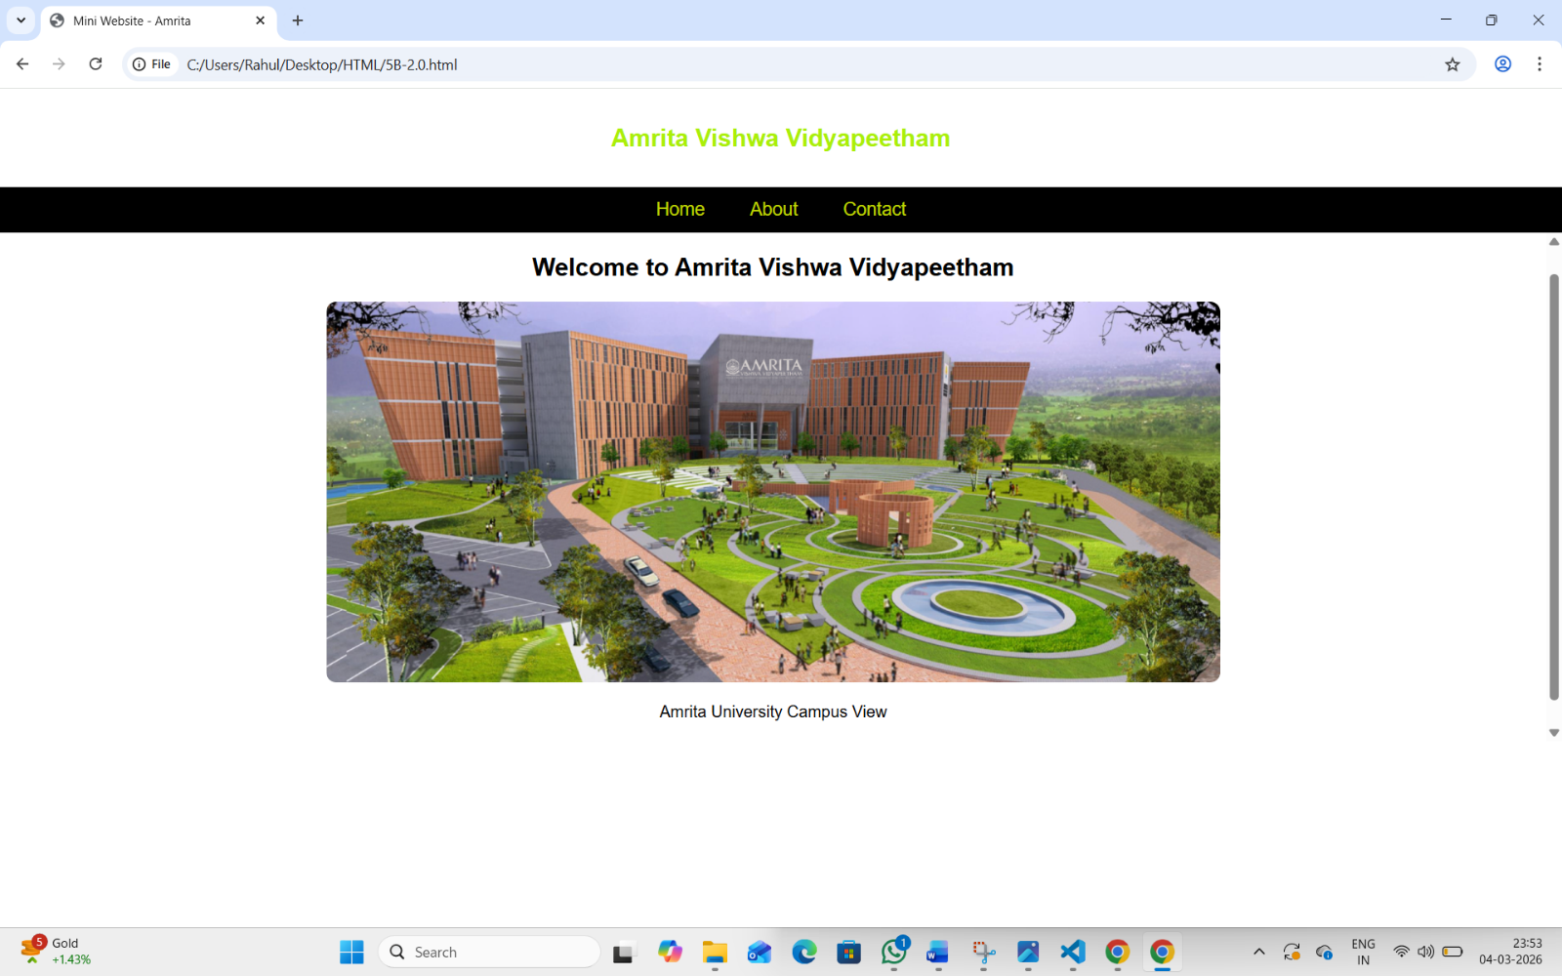
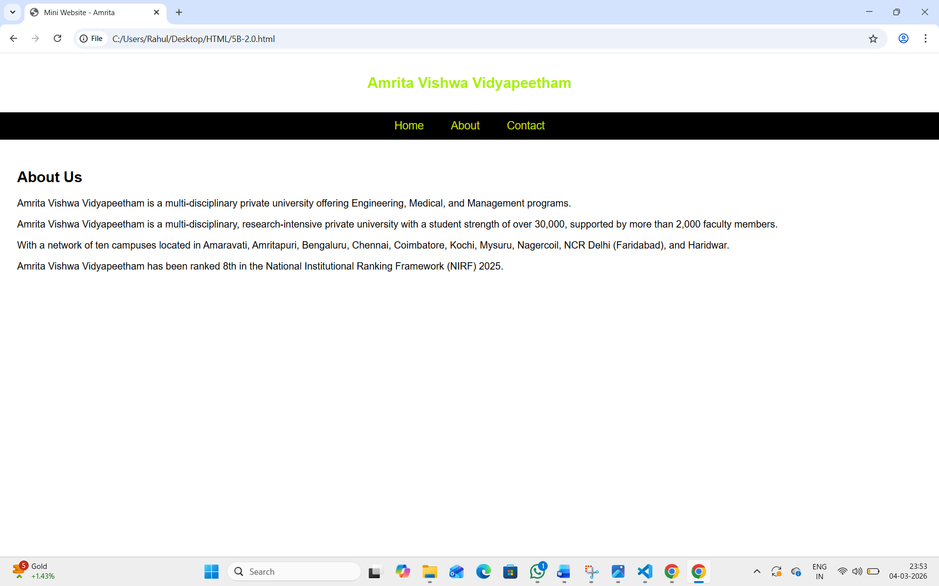
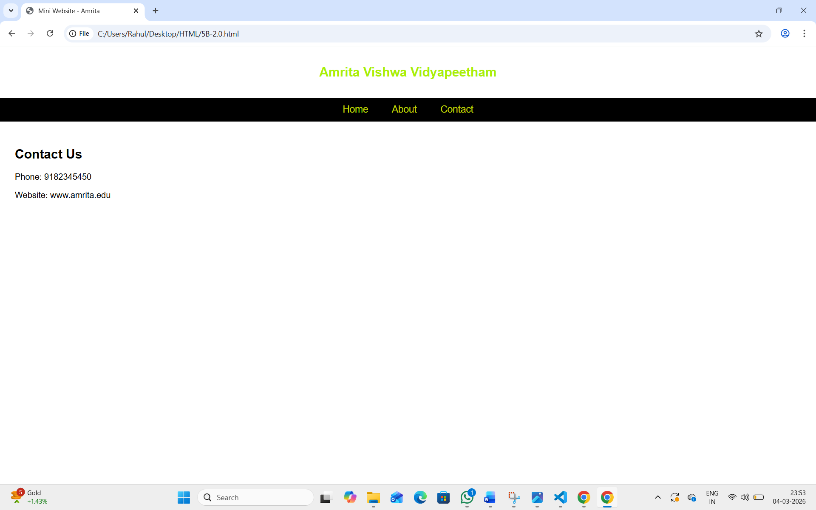

EXPLANATION OF TAGS:
<DOCTYPE html>: the <!DOCTYPE html> alement tells the web browser that this an HTML document or this is the latest version of HTML
<html>: the <html> element is the root element of an HTML web page
<head>:the <head> element will contain meta data about the HTML web page
<title>: the <title> element specifies a title for the HTML Page
<body>: the <body> element contains all visible content all visible content lika taxt, image, links tables, eto
<h>: we used <h> element for heading
<p>: we used <p> element for the paragraph
<div> :we use <div> element for encapsulating the the divisions and easy to modify and <button we use <button> element for button
<img>: we use <img> ting for displaying the image
5C.AIM: Design an amrita login page showing different campuses on the homepage. On clicking each campus, display campus details on the same page using HTML and CSS to design stylish webpage.
INPUT:
<!DOCTYPE html>
<html>
<head>
<title>Amrita Vishwa Vidyapeetham</title>

<style>
body{
margin:0;
font-family: Arial, sans-serif;
background: linear-gradient(to right, #d10606, #e01e1e);
}

.container{
height: 90%;
width: 90%;
margin: 30px auto;
background: rgb(235, 217, 217);
padding: 20px;
border-radius: 10px;
box-shadow: 0px 0px 10px rgb(10, 0, 0);
}

h1{
text-align: center;
color: rgb(249, 1, 50);
}

.campus-links{
text-align: center;
margin-bottom: 20px;
}

.campus-links a{
text-decoration: none;
margin: 0 15px;
color: rgb(18, 62, 120);
font-weight: bold;
}

.campus-links a:hover{
color: red;
}

.main{
display: flex;
gap: 20px;
}

.login{
width: 35%;
background: #f4f4f4;
padding: 20px;
border-radius: 10px;
}

.login input, .login select{
width: 90%;
padding: 10px;
margin: 10px 0;
border-radius: 5px;
border: 1px solid rgb(10, 10, 10);
}

.login button{
width: 90%;
padding: 10px;
background: black;
color: white;
border: none;
border-radius: 5px;
cursor: pointer;
}

.about{
width: 65%;
background: #dedbdb;
padding: 20px;
border-radius: 10px;
}

.campus-content{
display: none;
}

.campus-content:target{
display: block;
}

.campus-content img{
width: 70%;
height: 250px;
object-fit: cover;
border-radius: 10px;
margin-bottom: 15px;
}

</style>
</head>

<body>

<div class="container">

<h1><b>AMRITA VISHWA VIDYAPEETHAM</b></h1>

<div class="campus-links">
<a href="#amaravati">Amaravati</a>
<a href="#amritapuri">Amritapuri</a>
<a href="#chennai">Chennai</a>
<a href="#coimbatore">Coimbatore</a>
<a href="#mysore">Mysore</a>
<a href="#bangalore">Bangalore</a>
<a href="#kochi">Kochi</a>
<a href="#faridabad">Faridabad</a>
<a href="#nagaracoil">Nagaracoil</a>
<a href="#haridwar">Haridwar</a>
</div>

<div class="main">

<!-- Login Section -->
<div class="login">
<h3>Student Login</h3>
<input type="text" placeholder="Username">
<input type="password" placeholder="Password">
<input type="email" placeholder="Enter Email" required>
<input type="tel" placeholder="Enter Phone Number" required>

<select required>
<option value="">Select Course</option>
<option>B.Tech</option>
<option>M.Tech</option>
<option>BCA</option>
<option>MCA</option>
<option>BBA</option>
<option>MBA</option>
</select>

<button>Submit</button>
</div>

<!-- Campus Details Section -->
<div class="about">
<h3>About the Campus</h3>

<div id="amaravati" class="campus-content">
<img src="c:\Users\Rahul\Downloads\AMT.jpg" alt="Amaravati Campus">
<h4>Amaravati Campus</h4>
<p>Modern infrastructure and advanced engineering programs.A newer campus, expanding the university's presence in South India.</p>
</div>

<div id="amritapuri" class="campus-content">
<img src="c:\Users\Rahul\Downloads\amritapuri.jpg" alt="Amritapuri Campus">
<h4>Amritapuri Campus</h4>
<p>Main campus located in Kerala known for research excellence.Known for engineering and biotechnology.Situated near the beach, it focuses on, for example, biotechnology, engineering, and spiritual-based education.</p>
</div>

<div id="chennai" class="campus-content">
<img src="c:\Users\Rahul\Downloads\Chennai.jpg" alt="Chennai Campus">
<h4>Chennai Campus</h4>
<p>Strong industry collaboration and technical programs.Offers various engineering programs.</p>
</div>

<div id="coimbatore" class="campus-content">
<img src=""c:\Users\Rahul\Downloads\COIMBUTURE.jpeg alt="Coimbatore Campus">
<h4>Coimbatore Campus</h4>
<p>Known for innovation and academic excellence.Administrative headquarters, engineering, and business schools.Located in Ettimadai, it is the administrative headquarters and houses the main Schools of Engineering and Business. It features a large, green campus with extensive infrastructure (libraries, labs).</p>
</div>

<div id="mysore" class="campus-content">
<img src="c:\Users\Rahul\Downloads\Mysore.jpg" alt="Mysore Campus">
<h4>Mysore Campus</h4>
<p>Focused on computing and engineering education.</p>
</div>

<div id="bangalore" class="campus-content">
<img src="c:\Users\Rahul\Downloads\BLR.jpg" alt="Bangalore Campus">
<h4>Bangalore Campus</h4>
<p>Offers management and technology programs.Focuses on engineering and technology. Focuses on technology, with strong placement opportunities and proximity to the tech hub.</p>
</div>
<div id="kochi" class="campus-content">
<img src="c:\Users\Rahul\Downloads\BLR.jpg" alt="Kochi Campus">
<h4>Kochi Campus</h4>
<p>Known for its vibrant campus life and strong industry ties. Offers programs in engineering, management, and applied sciences.</p>
</div>
<div id="faridabad" class="campus-content">
<img src="c:\Users\Rahul\Downloads\Faridabad.jpg" alt="Faridabad Campus">
<h4>Faridabad Campus</h4>
<p>Located in Haryana, this campus offers programs in engineering and management with strong industry connections.</p>
</div>
<div id="nagaracoil" class="campus-content">
<img src="c:\Users\Rahul\Downloads\NGR.jpg" alt="Nagaracoil Campus">
<h4>Nagaracoil Campus</h4>
<p>Known for its serene environment and strong academic programs. Offers undergraduate and postgraduate programs in engineering, management, and applied sciences.</p>
</div>
<div id="haridwar" class="campus-content">
<img src="c:\Users\Rahul\Downloads\Haridwar.jpg"Haridwar Campus">
<h4>Haridwar Campus</h4>
<p>Located in Uttarakhand, this campus offers programs in engineering, management, and applied sciences with a focus on holistic education.</p>
</div>
</div>

</div>

</div>

</div>

</body>
</html>

OUTPUT:
Home Page:
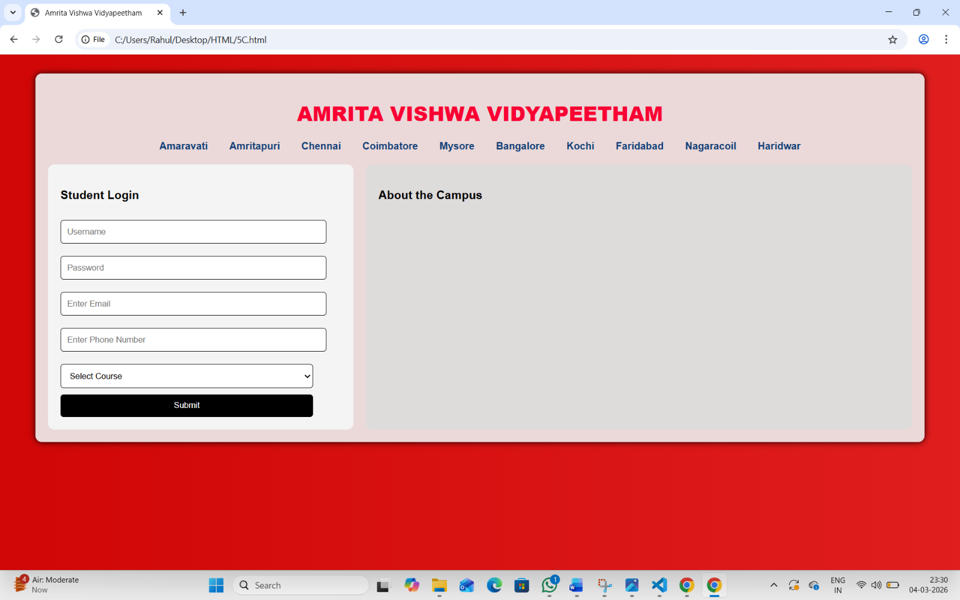
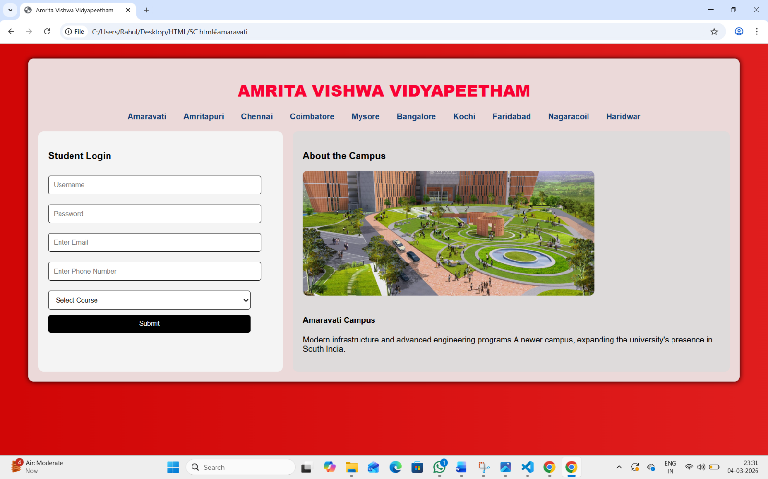
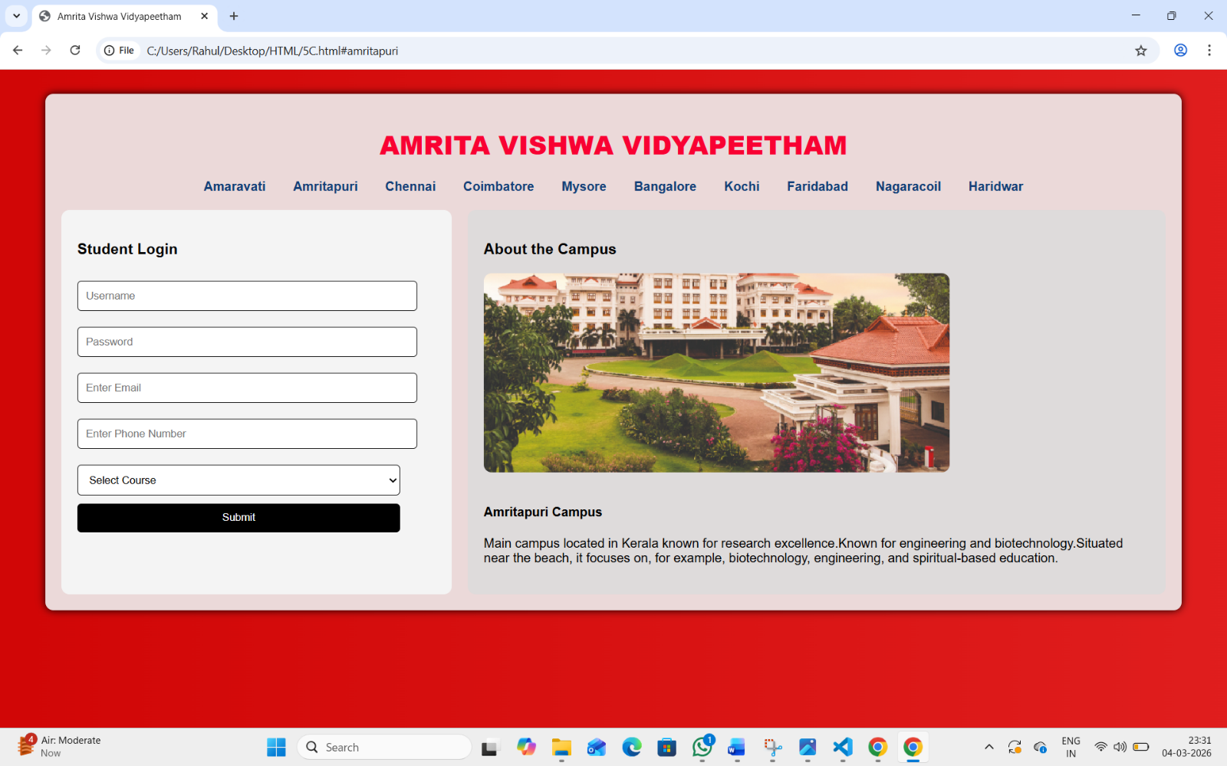
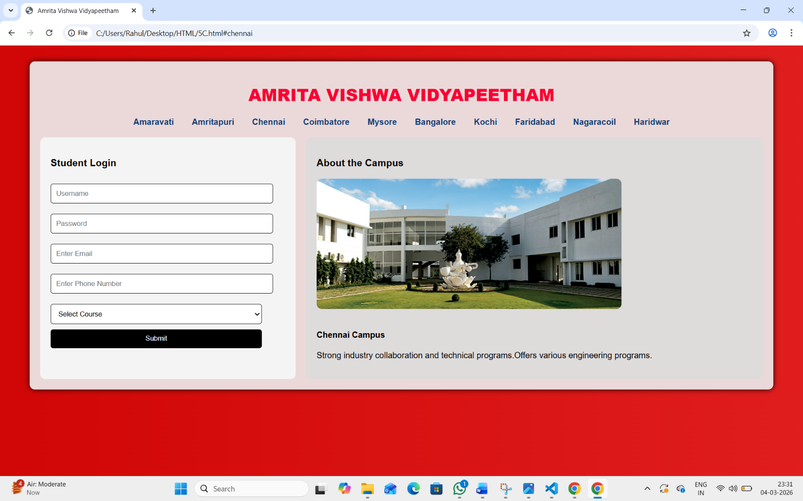
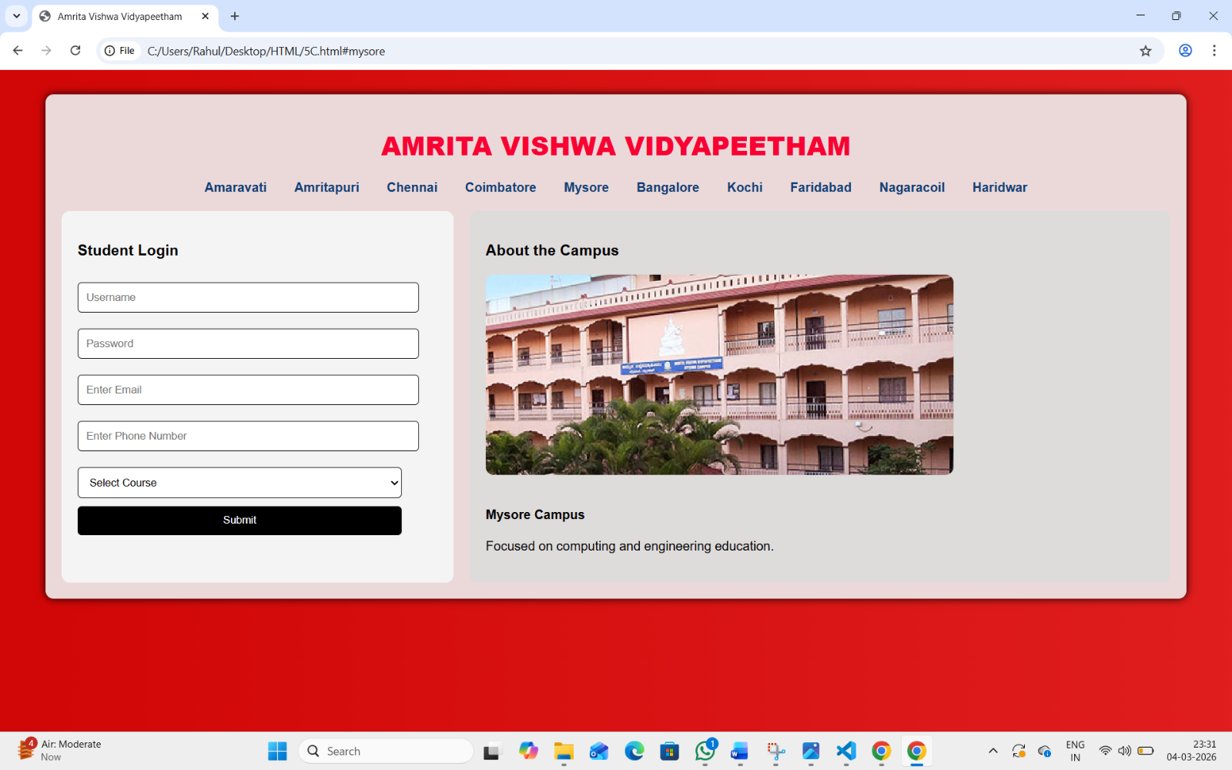
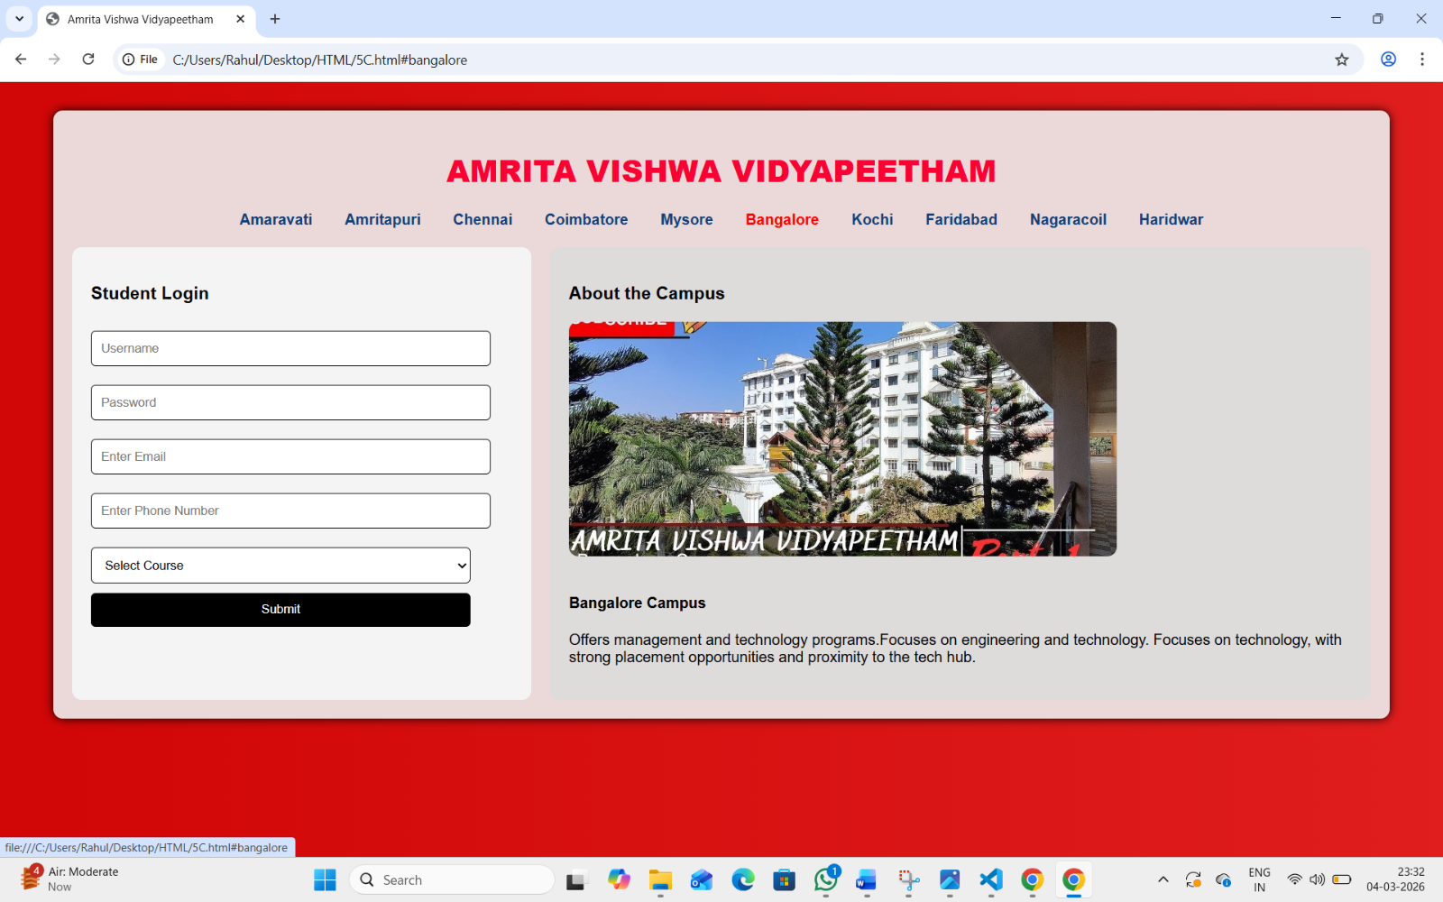
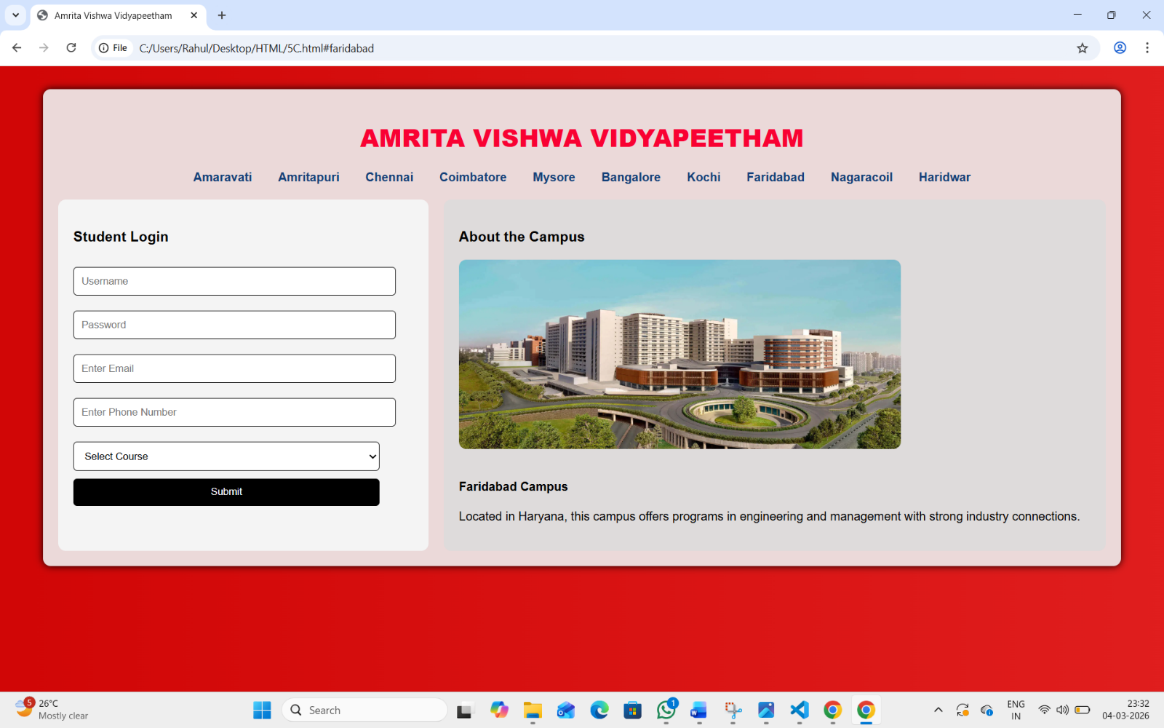
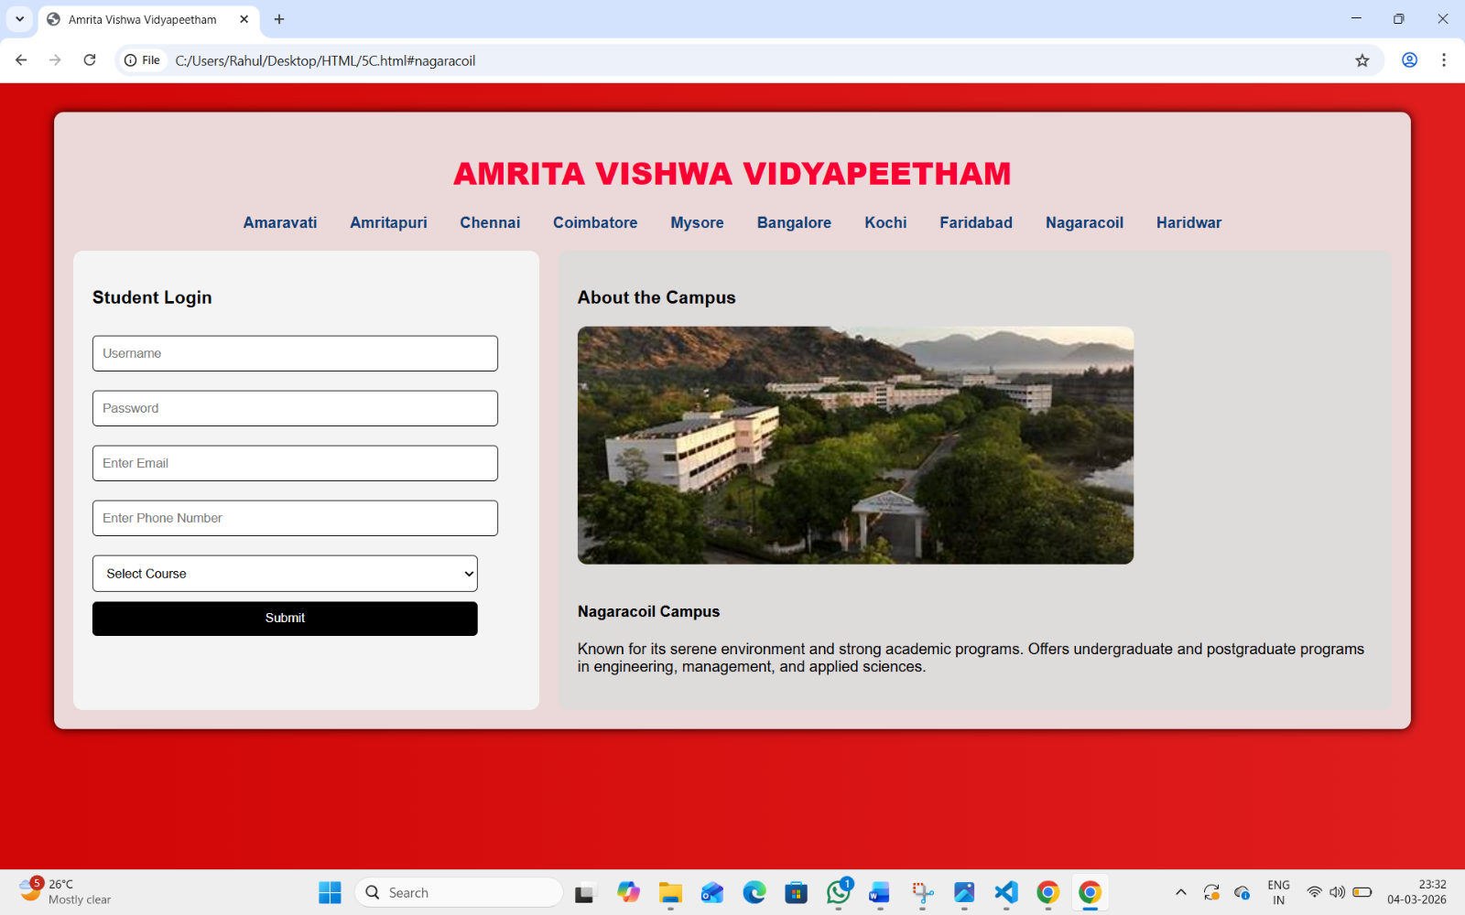
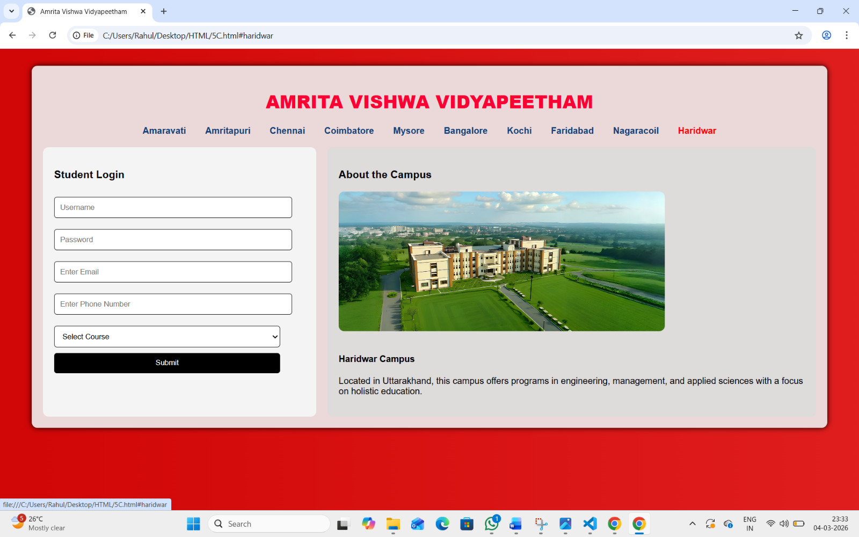
EXPLANATION:
1.This HTML and CSS code creates a webpage for Amrita Vishwa Vidyapeetham with a styled layout.
2.The page has a main heading and campus navigation links such as Amaravati, Chennai, Coimbatore, etc.
3.When a user clicks a campus link, the campus image and information appear using the :target CSS selector.
4.The left side of the page contains a Student Login form with fields like username, password, email, phone number, and course selection.
5.The right side shows the About Campus section with images and descriptions of different campuses.

WEEK-6
6A.AIM:Design a responsive E-Commerce application using the grid layout.This application should contain different categories of Products such as Electronics,Home Appliances,Clothing.Based on Category we select Corresponding Products Should be Displayed on the site bar.
INPUT:
CODE:
<!DOCTYPE html>
<html>
<head>
<title>E-Commerce Grid Layout</title>8

<style>
body{
margin:0;
font-family:Arial;
}

/* Grid Layout */
.container{
display:grid;
grid-template-columns:200px 1fr;
grid-template-rows:60px auto;
height:100vh;
}

/* Header */
.header{
grid-column:1/3;
background:#222;
color:white;
text-align:center;
padding:15px;
font-size:22px;
}

/* Sidebar */
.sidebar{
background:#f4f4f4;
padding:20px;
}

.sidebar button{
display:block;
width:100%;
padding:10px;
margin:10px 0;
border:none;
background:#333;
color:white;
cursor:pointer;
}

.sidebar button:hover{
background:#555;
}

/* Product Grid */
.products{
display:grid;
grid-template-columns:repeat(auto-fit,minmax(200px,1fr));
gap:15px;
padding:20px;
}

/* Product Card */
.card{
border:1px solid #ccc;
padding:10px;
text-align:center;
}

.card img{
width:100%;
height:150px;
object-fit:cover;
}

.card button{
margin-top:10px;
padding:8px;
background:green;
color:white;
border:none;
cursor:pointer;
}
</style>

</head>

<body>

<div class="container">

<div class="header">
Responsive E-Commerce Store
</div>

<div class="sidebar">
<h3>Categories</h3>
<button onclick="showCategory('electronics')">Electronics</button>
<button onclick="showCategory('home')">Home Appliances</button>
<button onclick="showCategory('clothing')">Clothing</button>
</div>

<div class="products" id="productArea">

<div class="card electronics">
<img src="https://via.placeholder.com/200">
<h4>Smartphone</h4>
<button>Buy Now</button>
</div>

<div class="card electronics">
<img src="https://via.placeholder.com/200">
<h4>Laptop</h4>
<button>Buy Now</button>
</div>

<div class="card home">
<img src="https://via.placeholder.com/200">
<h4>Washing Machine</h4>
<button>Buy Now</button>
</div>

<div class="card home">
<img src="https://via.placeholder.com/200">
<h4>Refrigerator</h4>
<button>Buy Now</button>
</div>

<div class="card clothing">
<img src="https://via.placeholder.com/200">
<h4>T-Shirt</h4>
<button>Buy Now</button>
</div>

<div class="card clothing">
<img src="https://via.placeholder.com/200">
<h4>Jeans</h4>
<button>Buy Now</button>
</div>

</div>

</div>

<script>
function showCategory(category){
let products=document.querySelectorAll(".card");

products.forEach(function(item){
if(item.classList.contains(category)){
item.style.display="block";
}else{
item.style.display="none";
}
});
}
</script>

</body>
</html>

OUTPUT:
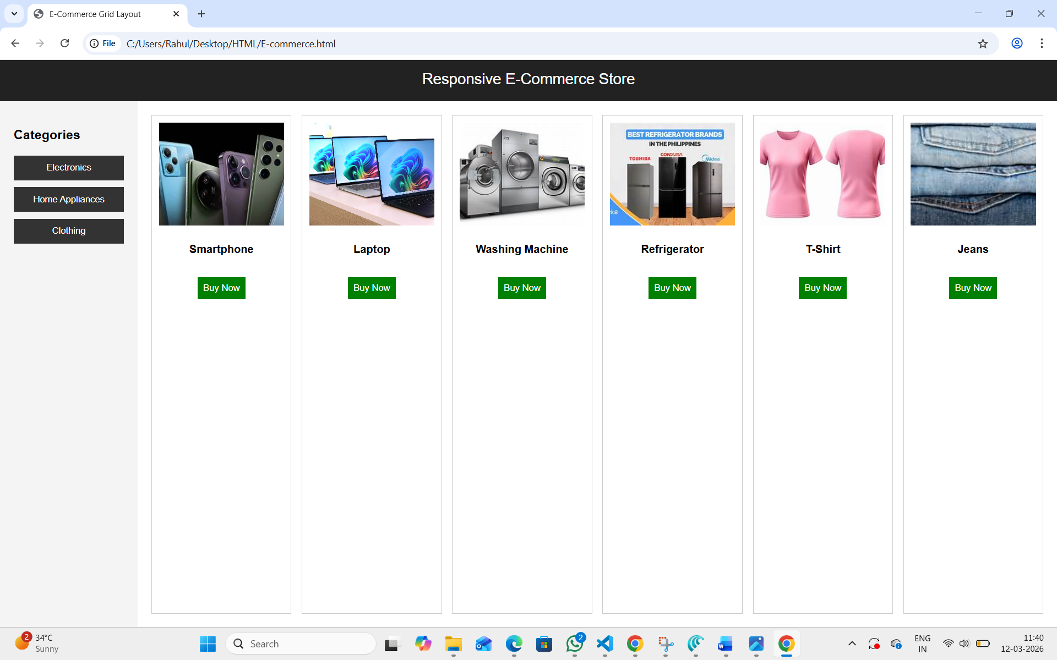
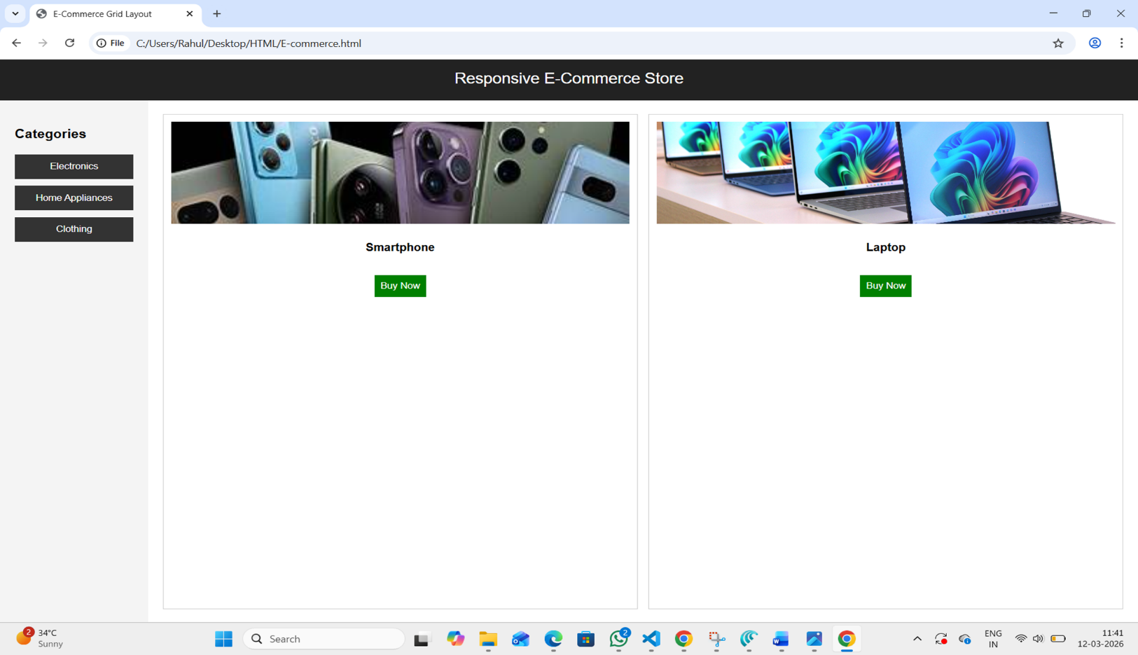

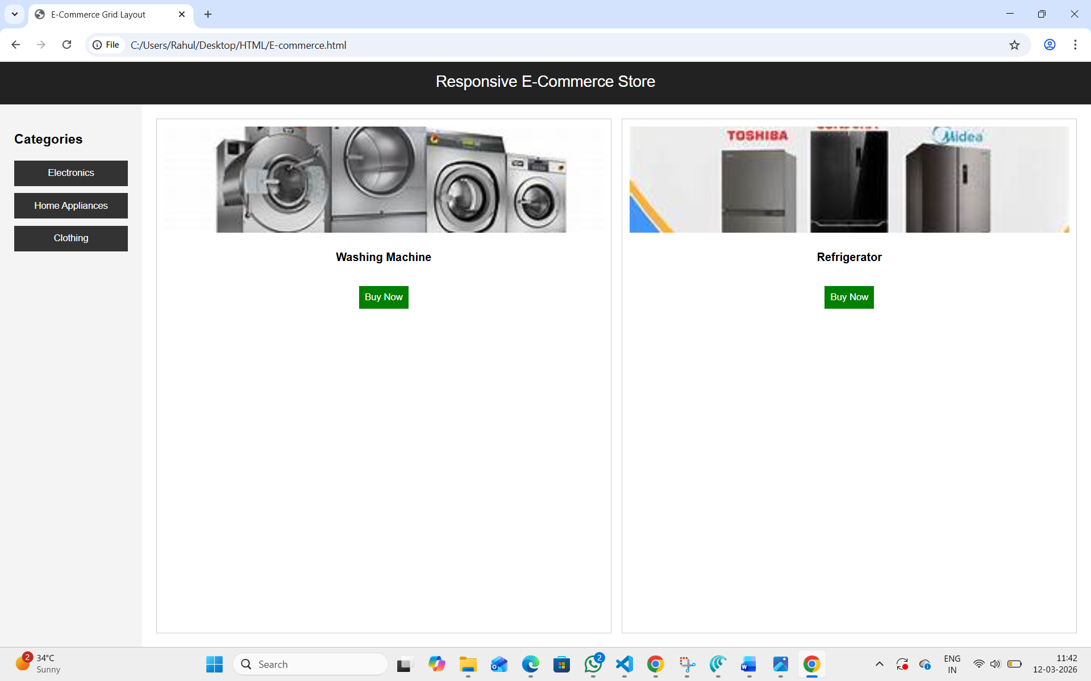
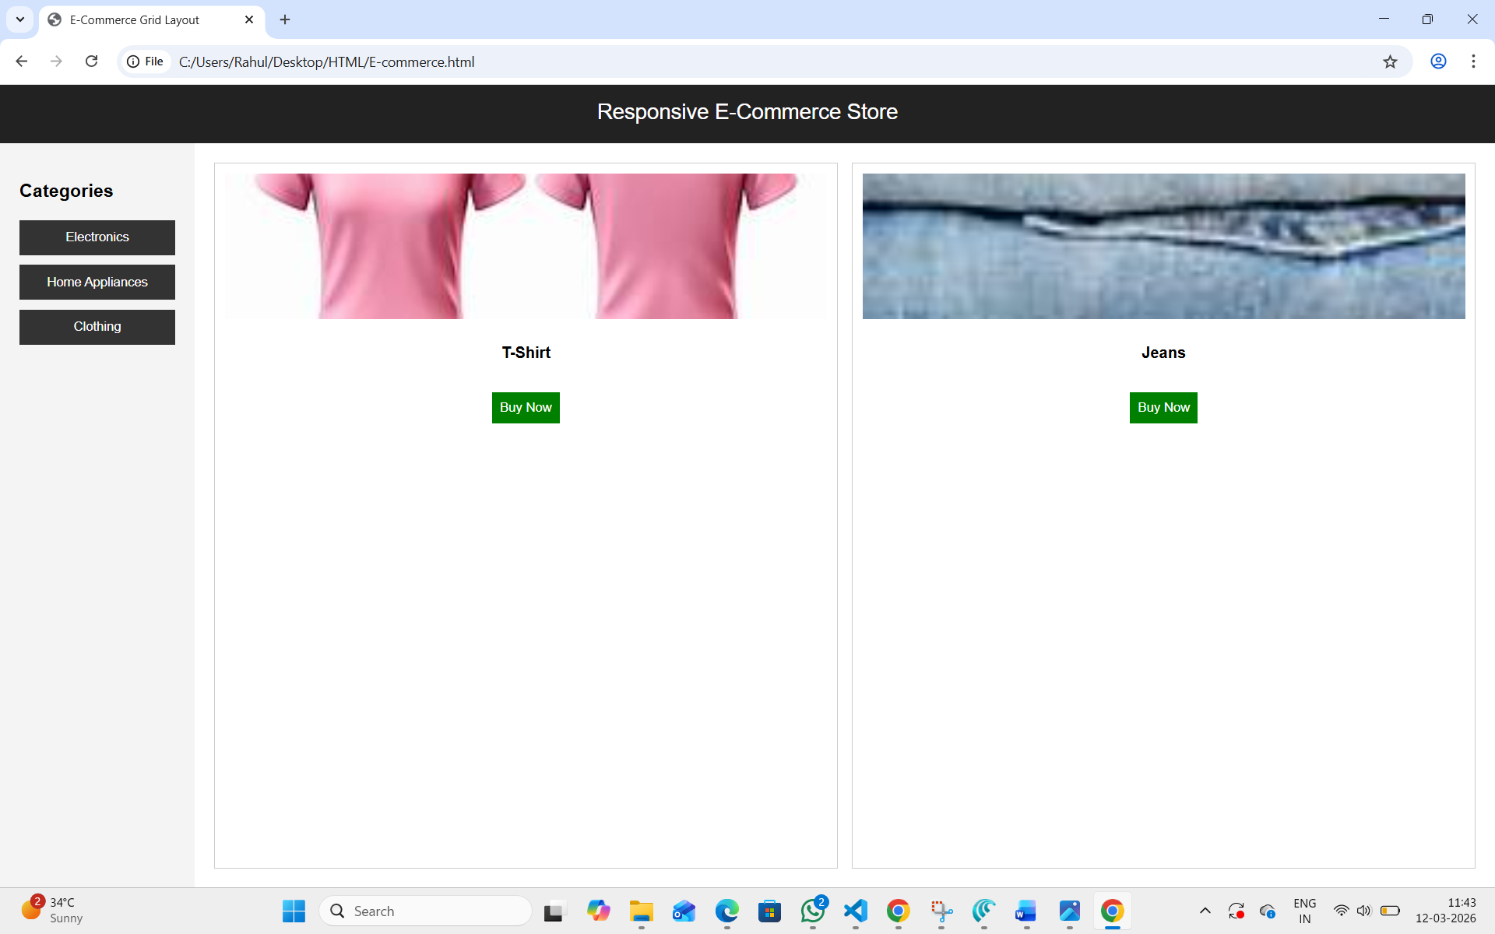
Explanation:
<DOCTYPE html> : the <!DOCTYPE html> element tells the web browser that this an HTML document or this is the latest version of HTML.
<html> : the <html> element is the root element of an HTML web page
<head> : the <head> element will contain meta data about the HTML web page
<title> : the <title> element specifies a title for the HTML Page
<body> : the <body> element contains all visible content all visible content like text , image , links ,
tables , etc
<h> : we used <h> element for heading
<p> : we used <p> element for the paragraph
<div>:we use <div> element for encapsulating the the divisions and easy to modify and
<button>: we use <button> element for button
<img>: we use <img> tag for displaying the image
<I frame>:we <iframe> tag to create link other webpages into it.
Week -7
7.A) Aim: create a GitHub account and create a repository in it and push all the week 6 code files in it.
Procedure :
Step 1: browse for GitHub and enter it.
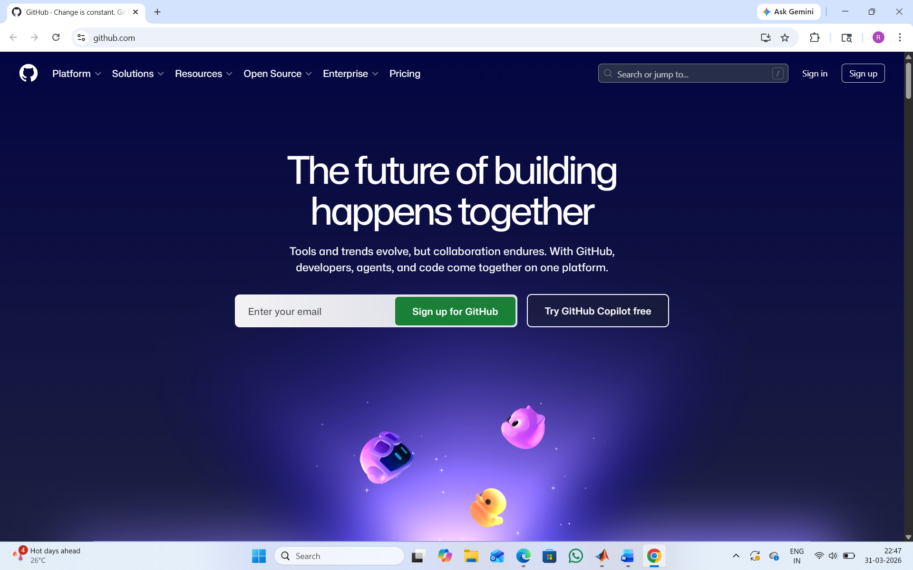

Step 2:login to GitHub account.
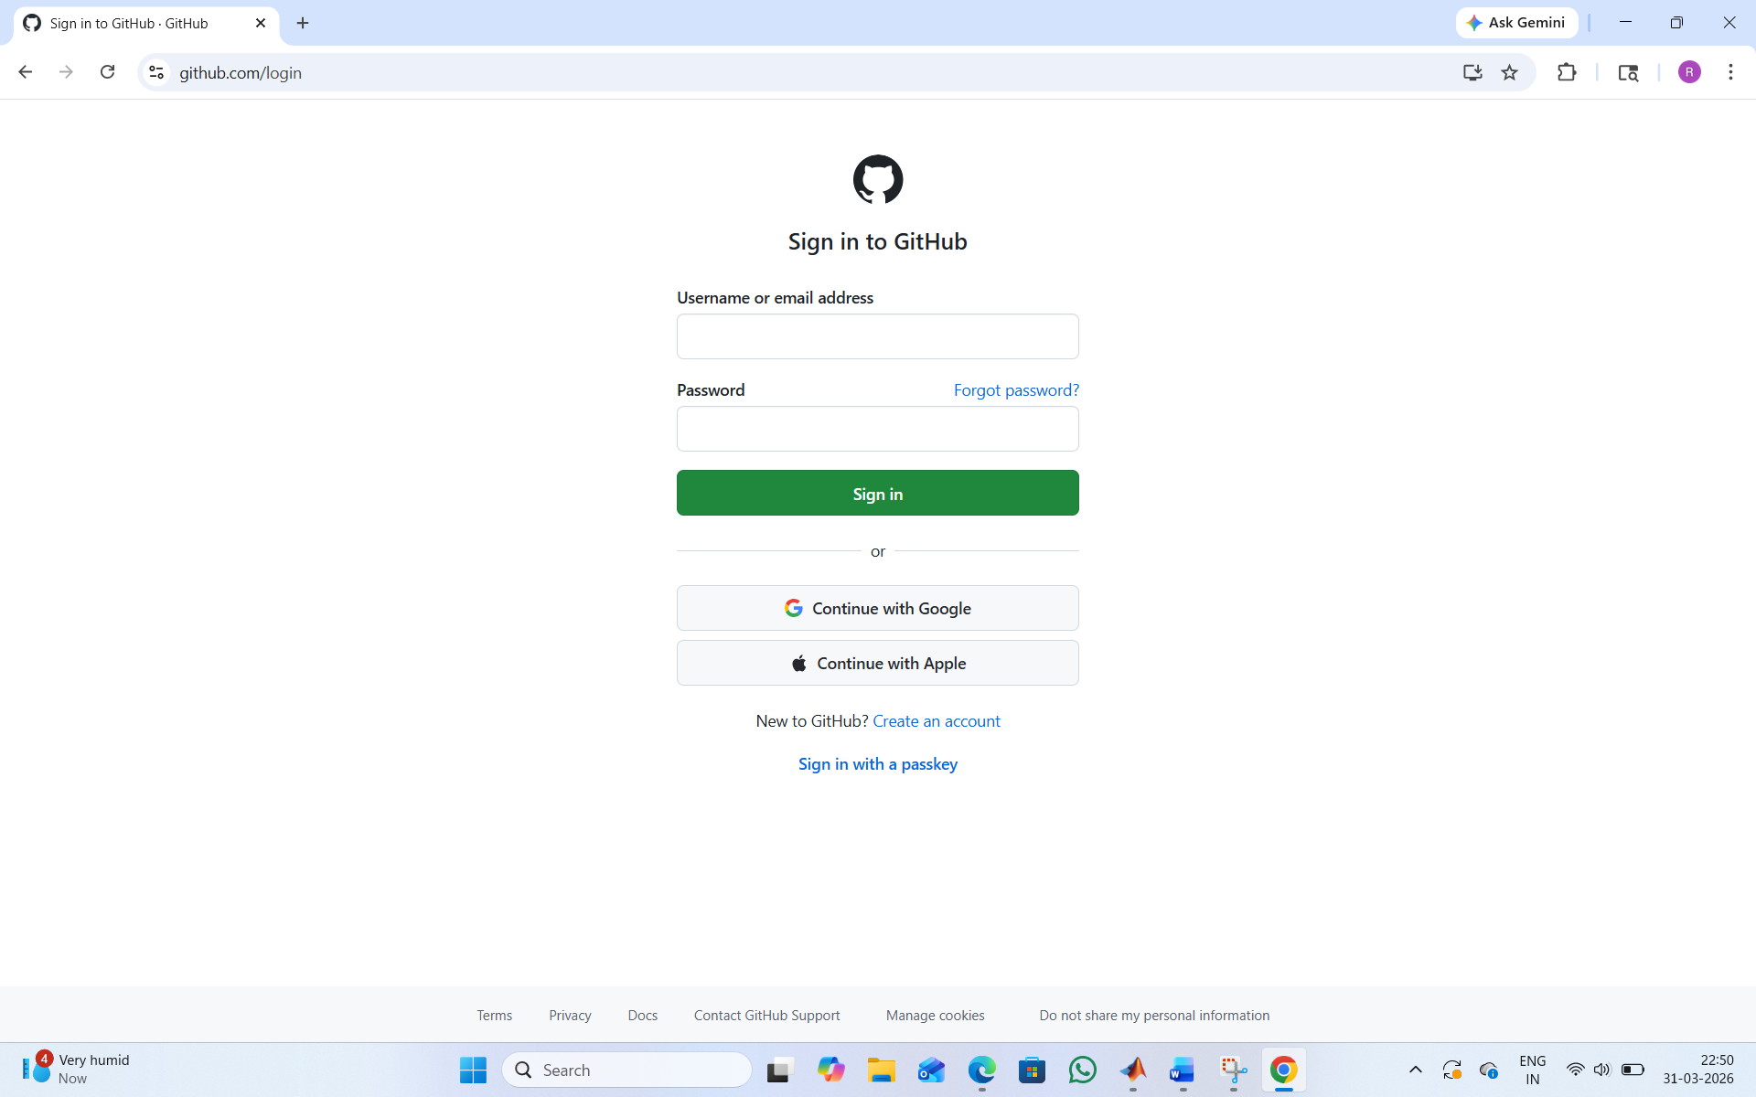
Step 3:create a repository after login by clicking new.
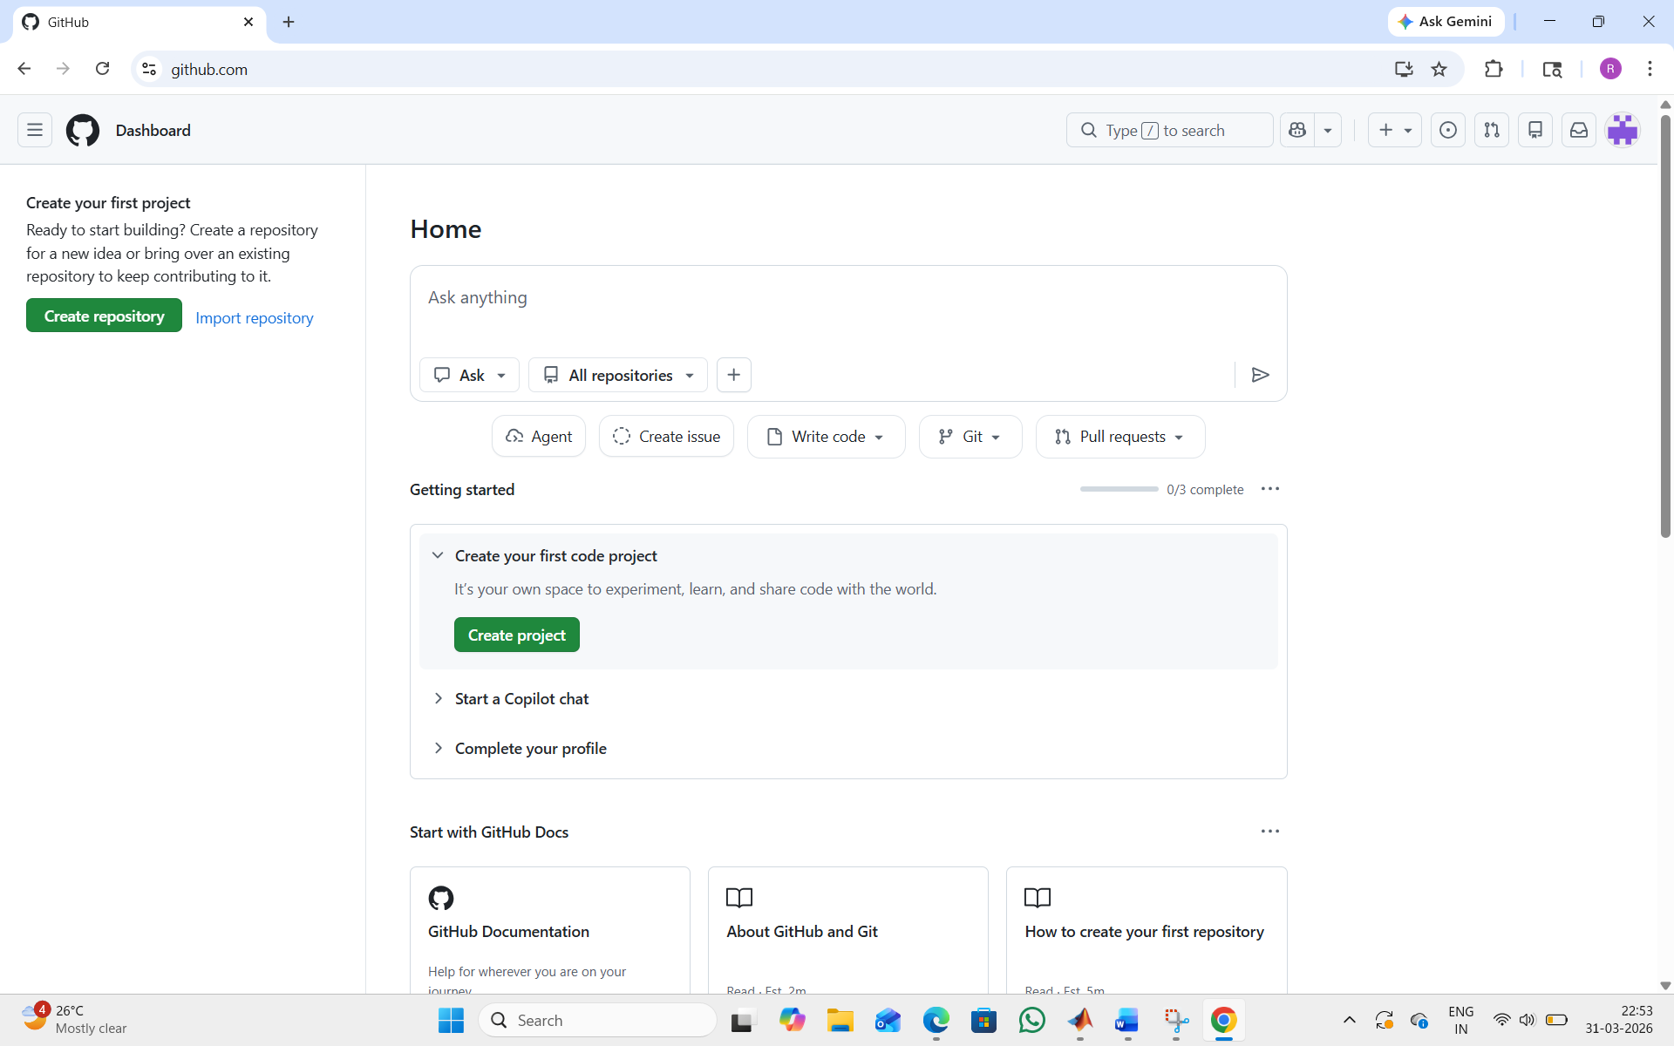

Step 4:specify the repository specifications.
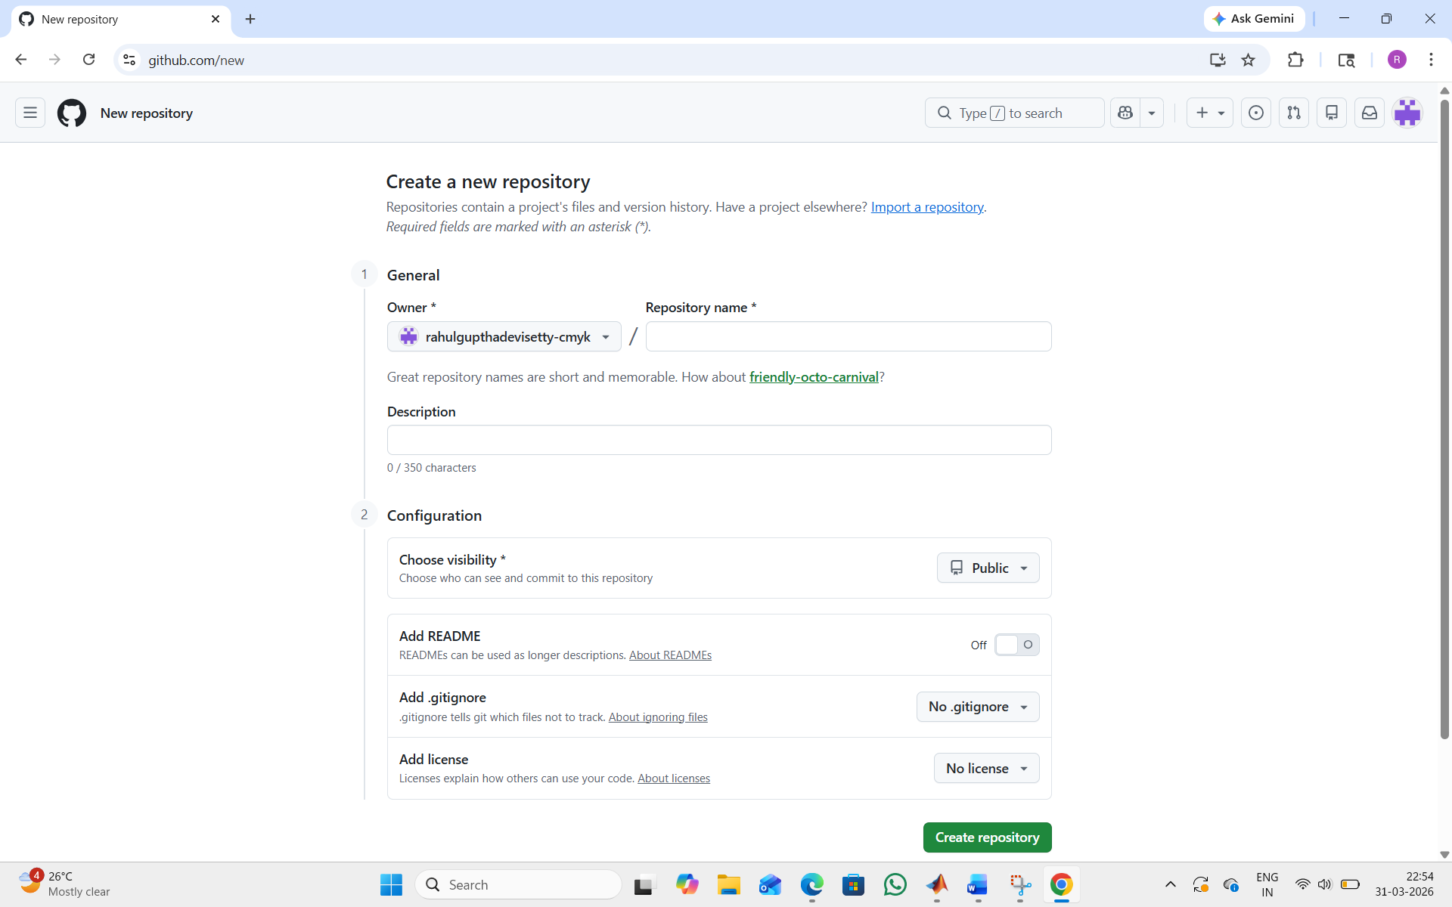
Step 5:Download GitHub desktop and Lauch it.
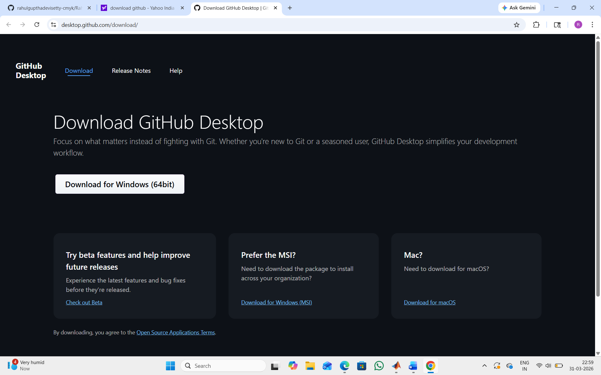

Step 6:add the repository to it .
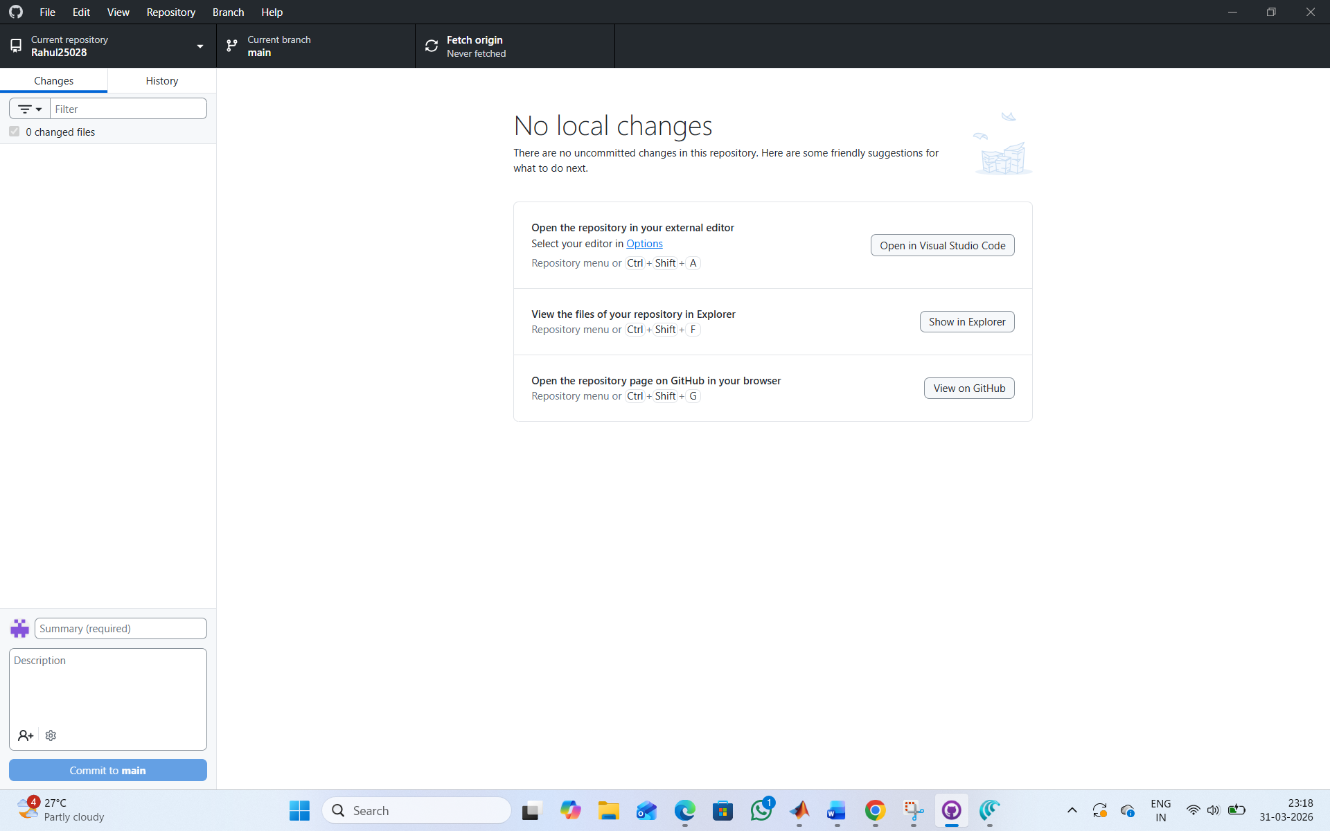
Step 7:add the vs code file to the GitHub desktop.

WEEK – 8
8A.)AIM: Create a webpage that displays a square that continusoly rotates 360 degrees using CSS Animations.
INPUT:
CODE:
<!DOCTYPE html>
<html>
<head>
<title>Rotating Square</title>
<style>
body {
margin: 0;
height: 100vh;
display: flex;
flex-direction: column;
justify-content: flex-start;
align-items: center;
background-color: #2f3e46;
font-family: Arial, sans-serif;
padding-top: 50px;
}
.square {
width: 120px;
height: 120px;
background: #ffffffcc;
border-radius: 12px;
box-shadow: 0 8px 25px rgba(0, 0, 0, 0.2);
animation: rotate 3s linear infinite;
}
@keyframes rotate {
from {
transform: rotate(0deg);
}
to {
transform: rotate(360deg);
}
}
</style>
</head>
<body>
<h1 style="color: #fff;">Rotating Square</h1>
<div class="square"></div>
</body>
</html>
OUTPUT:
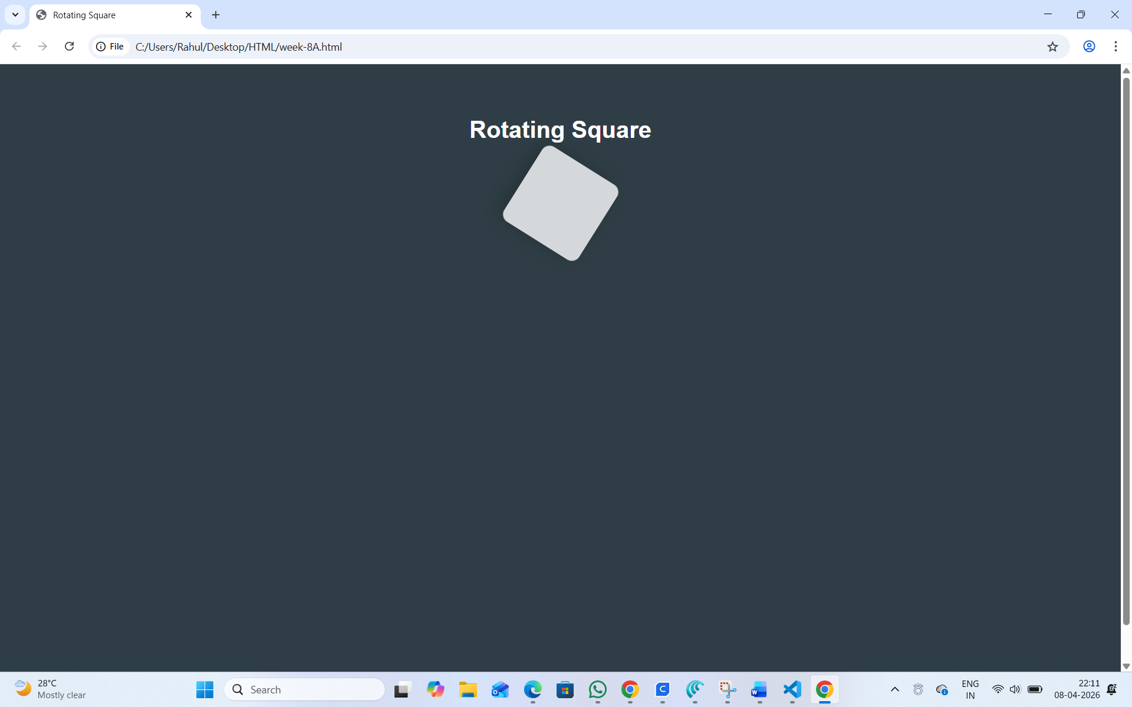
Explanation:
1)This code creates a rotating square animation using HTML and CSS.
2)The <body> is styled with flexbox to center the content horizontally.
3)A dark background color is applied to make the square visible clearly.
4)The .square class creates a 120px × 120px white square with rounded corners and shadow.
5)The animation property is used to rotate the square continuously.
rotate 3s linear infinite means it rotates in 3 seconds, at constant speed, forever.
6)The @keyframes rotate defines the animation from 0 degrees to 360 degrees.
7)The <h1> tag displays the title "Rotating Square" above the square.
Overall, the code demonstrates a simple CSS animation effect.
8B.)AIM:Create a ball that move up and down continuously using CSS Animations.
INPUT:
CODE:
<!DOCTYPE html>
<html>
<head>
<title>Bouncing Ball</title>
<style>
body {
margin: 0;
height: 100vh;
display: flex;
flex-direction: column;
align-items: center;
justify-content: flex-start;
background: #2f3e46;
}
h1 {
margin-top: 20px;
color: #ffffff;
}
.ball {
width: 80px;
height: 80px;
background: #ffffff;
border-radius: 50%;
margin-top: 120px;
animation: bounce 1.5s ease-in-out infinite;
}
@keyframes bounce {
0% {
transform: translateY(0);
}
50% {
transform: translateY(-120px);
}
100% {
transform: translateY(0);
}
}
</style>
</head>
<body>
<h1>Bouncing Ball</h1>
<div class="ball"></div>
</body>
</html>
OUTPUT:
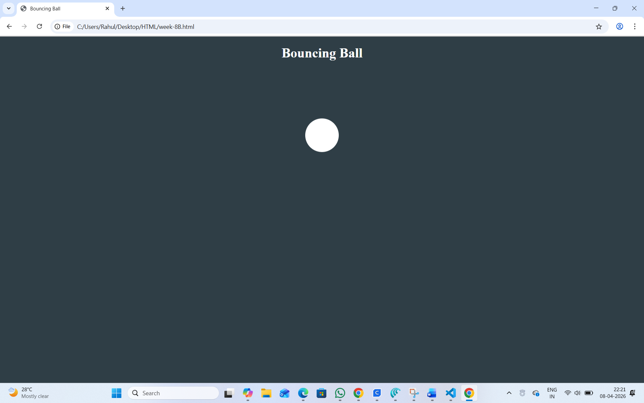
Explanation:
<DOCTYPE html> : the <!DOCTYPE html> element tells the web browser that this an HTML document or this is the latest version of HTML
<html> : the <html> element is the root element of an HTML web page
<head> : the <head> element will contain meta data about the HTML web page
<title> : the <title> element specifies a title for the HTML Page
<body> : the <body> element contains all visible content all visible content like text , image , links,tables , etc
<h> : we used <h> element for heading
<div>:we use <div> element for encapsulating the the divisions and easy to modify and
@keyframes:we use @keyframes for animation from starting to end transformation.
We used animation shorthand property for these things to mention the animations preferences and
use keyframes for mentioning the positions of the animation and used style attribute and some value
properties for look and we used internal css in it .
8C.)AIM:Create a circle that moves horizontally and rotates At the same time.
INPUT:
CODE:
<!DOCTYPE html>
<html lang="en">
<head>
<title>Moving Rotating Circle</title>
<style>
body {
margin: 0;
height: 100vh;
display: flex;
flex-direction: column;
align-items: center;
justify-content: flex-start;
background: #2f3e46;
overflow: hidden;
}
h1 {
margin-top: 20px;
color: #ffffff;
}
.circle {
width: 80px;
height: 80px;
background: #ffffff;
border-radius: 50%;
margin-top: 120px;
animation: moveRotate 3s linear infinite;
}
@keyframes moveRotate {
0% {
transform: translateX(-150px) rotate(0deg);
}
50% {
transform: translateX(150px) rotate(180deg);
}
100% {
transform: translateX(-150px) rotate(360deg);
}
}
</style>
</head>
<body>
<h1>Moving Rotating Circle</h1>

<div class="circle"></div>
</body>
</html>
OUTPUT:
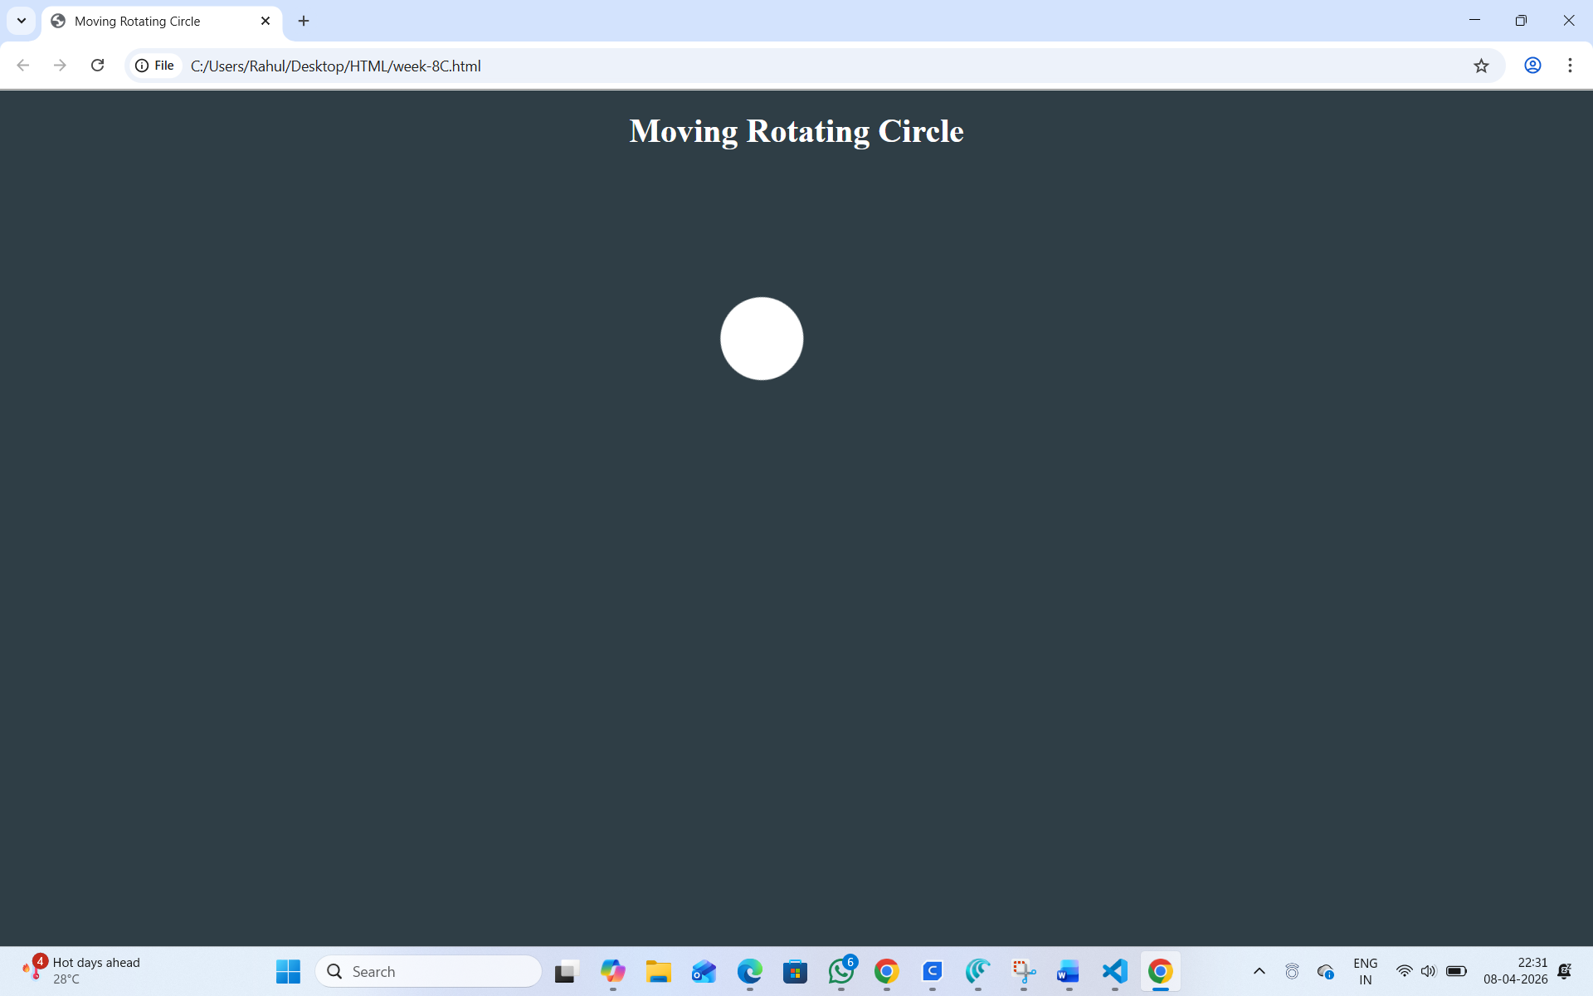
Explanation:
<DOCTYPE html> : the <!DOCTYPE html> element tells the web browser that this an HTML document or this is the latest version of HTML
<html> : the <html> element is the root element of an HTML web page
<head> : the <head> element will contain meta data about the HTML web page
<title> : the <title> element specifies a title for the HTML Page
<body> : the <body> element contains all visible content all visible content like text , image , links , tables , etc
<h> : we used <h> element for heading
<div>:we use <div> element for encapsulating the the divisions and easy to modify and
@keyframes:we use @keyframes for animation from starting to end transformation. We used animation shorthand property for these things to mention the animations preferences and use keyframes for mentioning the positions of the animation and used style attribute and some value properties for look and we used internal css in it .

